

Upwood Primary School Prospectus

For School Admissions from Autumn 2014 to Summer 2015
Table of Contents
WelCome to Upwood Primary School 3
ABOUT OUR SCHOOL 3
School Contact Details 3
School Ethos 3
School Location 4
Inclusion 5
Accessibility 5
Racial Equality 5
The Governing Body 6
Admissions 6
Class Organisation 7
Daily Routine 7
A Typical Week for a Key Stage 1 Pupil 8
A Typical Week for a Key Stage 2 Pupil 8
School Dress 9
Absence from School 9
Upwood Small to Tall 10
Upwood Primary School Parent Teacher Association (PTA) 10
CURRICULUM 11
Introduction to the National Curriculum 11
Foundation Stage 11
School Curriculum 12
Special Educational Needs 17
Abbey School Cluster Area (ASCA) 17
Assessment and Testing 18
Homework 18
Educational and Residential Visits 18
COMMUNICATION WITH PARENTS/carers 19
Keeping In Contact 19
School Policy Documents 19
Reports and Consultation Evenings 19
Home-School Agreement 19
Newsletters and Notices 19
E-Communication 20
Freedom of Information Act (FOIA) 20
Complaints Procedure 20

HEALTH AND WELFARE 21
Health Care 21
First Aid 21
Medicines 21
Positive Behaviour 22
Anti-bullying 22
Physical Intervention 22
Safeguarding and Child Protection 22
OTHER ASPECTS OF SCHOOL LIFE 23
School Security 23
Travelling to School 23
Cycling 24
Cycles in School 24
Health Promoting School 24
Personal Property 24
Lost Property 24
Clubs………………………………………………………………………………… 25
Volunteers In School 25
The Next Step 25
And Finally... 25
Appendix A (Documents Referred to in the School Prospectus) 26
Appendix B (Attendance Statistics 2013) 26
Appendix C (Key Stage 1 Test Results 2013) 27
Appendix D (Key Stage 2 Test Results 2013) 28

WelCome to Upwood Primary School
Our Prospectus aims to give you an overview of our school and an insight into how our school functions. It contains information that will be relevant throughout your child’s time at Upwood. In addition, we refer to a number of School Policy Documents, a full list of which can be found in Appendix A to this Prospectus. These documents are normally accessible via our school website or copies can be obtained, upon request, from the School Office.
We hope you will find this Prospectus helpful. We feel, however, that nothing can surpass the reassurance that is to be gained from the personal contact that only a visit to the school will bring.
We are a village school and take pleasure in, and are proud to be, an integral part of village life and the local community. We participate in a range of activities both in school and in the wider community.
We aim to provide a friendly and secure school environment; offer a rich and varied curriculum and give every child the opportunity to achieve their potential in academic attainment, creativity, physical activities, attitudes and personal conduct. We want our children to value effort as well as achievement, and to develop self awareness and sensitivity towards others in order to live harmoniously within the school and wider community.
We aim to work closely with you throughout your child’s time at our school. We ask you and your child to join us by signing our Home-School Agreement. By working together we can ensure that your child progresses in a happy atmosphere of encouragement, praise and high motivation.

ABOUT OUR SCHOOL

School Contact Details
Upwood Primary School is a Cambridgeshire County Council Community School.
Our Address:
- Upwood Primary School
Ramsey Road
Upwood
Huntingdon
Cambridgeshire
PE26 2QA
- Telephone: 01487 813510
- Fax: 01487 812019
- e-mail: office@upwood.cambs.sch.uk
- website: http://www.upwood.cambs.sch.uk
School Hours: 9:00am – 3:30pm
Office Hours: 8:30am – 4:00pm Daily

Age Range: 4 – 11 year olds
School years: F (Foundation), Y1, Y2, Y3, Y4, Y5 and Y6
Head Teacher: Mrs Whitelaw
Senior Leadership Team: Miss Clarke, Mrs Myles-Gardiner
School Secretary: Mrs Damant
Chair of Governors: Mr Whybrow

School Ethos
Our team at Upwood Primary School is dedicated to providing a positive and stimulating education for each child within a secure and happy environment.
The character of our school reflects our belief in developing mutual values of respect, integrity, kindness, tolerance and fairness. These values underpin the relationships we build between staff, pupils, families and the wider community. They inform school policy decisions and are integral to our day-to-day activities throughout the school. We believe in encouraging our children through demonstrating positive behaviour and attitudes.
Through our balanced and broad-based curriculum we provide challenging and relevant learning experiences to enable our pupils to develop intellectually, socially, emotionally and personally. Our careful assessment of each child allows us to set accurate and realistic goals to motivate each pupil to achieve their full potential. Trial and error is a natural, and valuable, process of learning and we acknowledge and reward contribution and effort as well as results.
We value the unique potential within each of our pupils and celebrate the diversity of ability and achievement that our school community comprises. All children can flourish when they feel accepted and we strive to create a safe and supportive environment where they can explore and experiment with their learning.

School Location
Founded in 1871, and originally located in the centre of the village, Upwood Primary School relocated to its present site in 1960.
Our school premises provide generous accommodation that includes seven teaching areas all with their own practical workspaces; a central hall, separate dining room, library, reading areas, school offices and kitchen.
At the front of the school there is a large play area including an all-weather hard court games area. To the rear of the building there is an enclosed split-level courtyard, mixing hard landscaped areas with lawn, flower beds, pergolas and shrub borders. The Upper Courtyard is equipped with picnic benches. The Courtyard areas are also used as outdoor classrooms providing stimulation for artwork, opportunities for gardening and science projects as well as reading and story-telling.
Adjacent to the Upper Courtyard is an environmental area planted as meadowland, adding both colour and educational interest to our surroundings.
Beyond the courtyard is the heated outdoor swimming pool which is used during the second half of the summer term and provides a valuable opportunity for our younger pupils. Across the back of the school grounds is our large playing field with running track and football pitch.

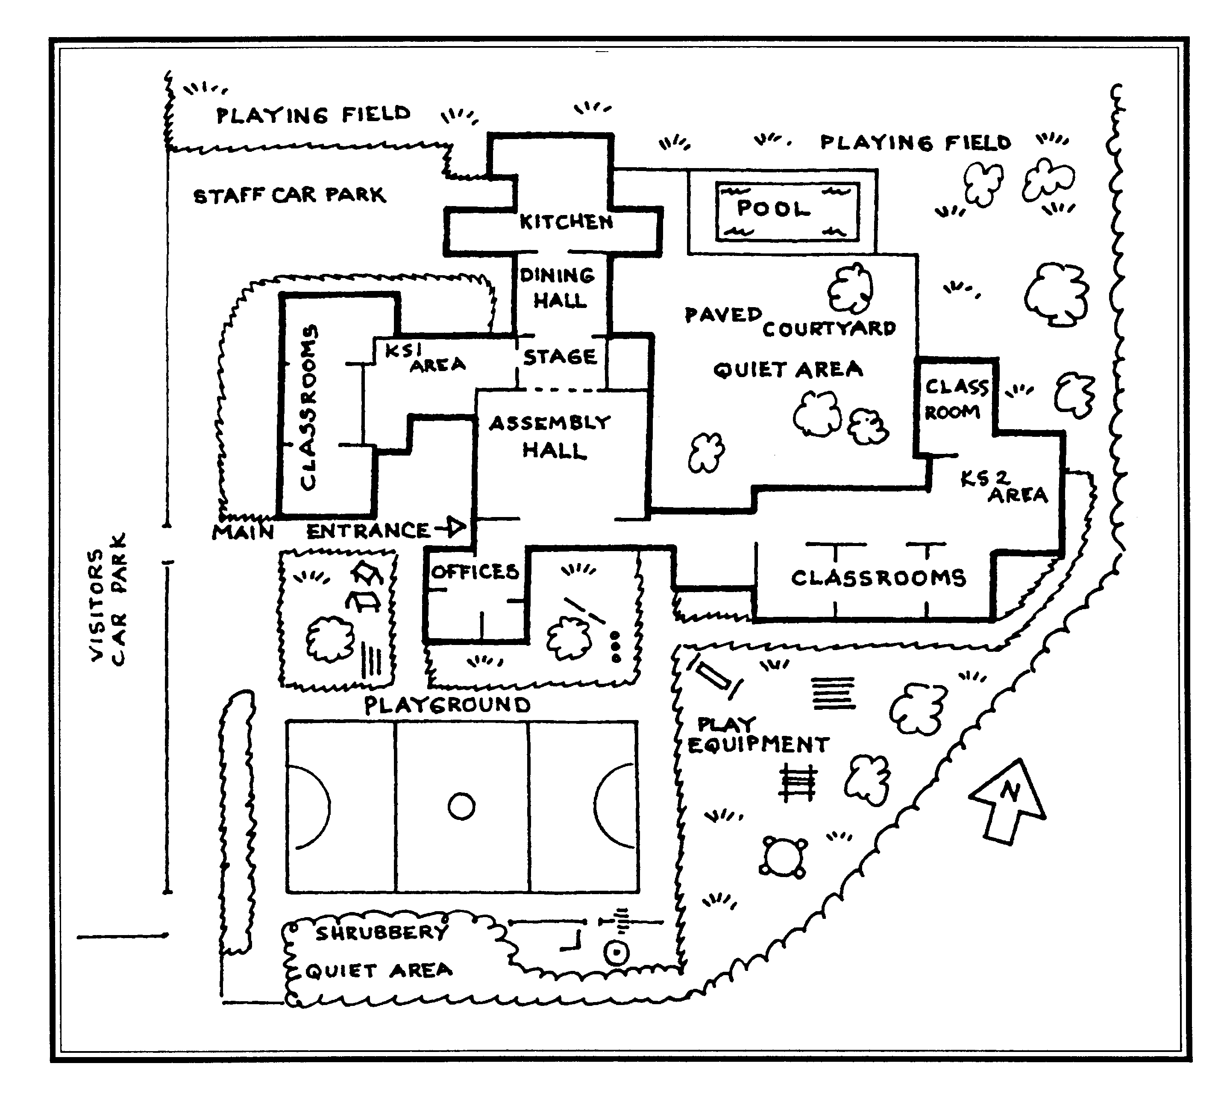
FOUNDATION OUTDOOR AREA

Inclusion
Upwood Primary School is an inclusive school, and the education we deliver reflects the core values of our policy. The ethos of the school supports the development of self-respect and self-esteem in all pupils, staff and the community it serves. We place a high value on diversity and treat every member of our school as an individual. In this way we aim to meet the needs of all, taking account of gender, ethnicity, culture, religion, language, sexual orientation, age, ability, disability and social circumstances.
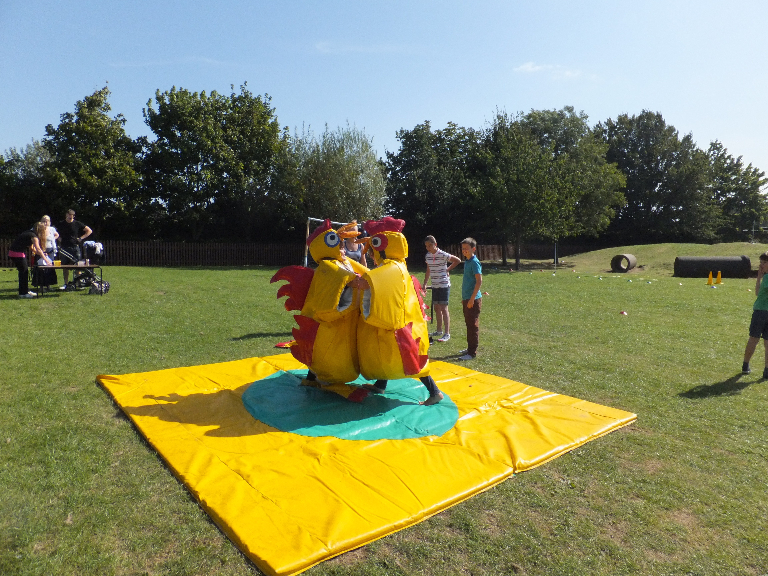
At the Summer Fayre
We believe education is a route to equal opportunity for all. Our staff are aware of the need for the curriculum to reflect cultural diversity. We ensure that the classroom is an inclusive environment in which all children feel all contributions are valued.

Accessibility
We aim to make all our children welcome and to look forward to their school day. Every child is different and we view differences as an opportunity for adults and children alike to learn more about ourselves.
If your child has a disability she or he will be treated no less favourably than other applicants for admission. We make reasonable adjustments to ensure that pupils with disabilities are not placed at a substantial disadvantage. Our accessibility plan (available at the School Office) describes proposals planned to improve physical access to the school, access to the curriculum and access to written information.
The school has a policy for supporting children with special educational needs which is revised every year. A copy of this policy is available. Our aim is for all children to have access to all aspects of school life, as far as is reasonable and practicable.
We aim to prevent disabled pupils in our school being placed at a substantial disadvantage. We will take all reasonable steps to ensure that people with a disability are not treated differently without lawful justification. We will make reasonable adjustments for disabled pupils and we will know we have succeeded when disabled pupils are participating fully in school life.
In order for effective partnership working between home and school to take place, we anticipate that parents/carers will want to:
- inform the school at the earliest opportunity if their child has a disability and the exact nature of it;
- provide the information the school needs to plan effectively for the child to be a full member of the school community;
- acknowledge that when deciding whether an adjustment is reasonable, one of the factors the Head Teacher must consider is the effect of the proposed change on all members of the school community;
- recognise the importance of school and home working in partnership.

Racial Equality
The Governors and staff of Upwood Primary School positively recognise the ethnic and cultural diversity within our modern society and oppose any form of racism, prejudice and discrimination. The school supports diversity and the positive role it plays within the school. Our staff fosters a positive atmosphere of mutual respect and trust amongst pupils from all ethnic groups. Adults in school take care to lead through example, demonstrating high expectations of all pupils
We believe our children benefit from Staff, Parents/Carers and Governors working in partnership to help them develop values and attitudes appropriate for the multi-cultural society in which they live and participate. We appreciate the special responsibility this is and our ultimate aim is to ensure equal value and respect to all cultures.

The Governing Body
The Governors of Upwood Primary School are a diverse group of local people who share a commitment to the education and welfare of the children in our care and the continued development of the school for the benefit of future generations. Every aspect of the life and conduct of our school is overseen by the Governing Body.
The Governing Body has a general responsibility for the effective management of the school. This includes establishing, with the Head Teacher, the aims and policies of the school, ensuring the National Curriculum is provided, the setting and control of the school budget and the appointment of staff.
Our Governing Body comprises Staff governors, Parent governors, Local Authority governors and Community governors. Much of their work is carried out through meetings, committees and working groups. Our Governors do also spend time in school, meeting and working with the staff and pupils. The Minutes of the Governing Body meetings and a copy of ‘Members of the Governing Body’ are available to all parents/carers.

Admissions
Upwood Primary School is a Cambridgeshire County Council Community Primary School serving the parishes of Upwood, the Raveleys and Wistow. We educate children from age 4 through to 11 years old. All children attend school from the September of the academic year in which they will be 5 years old.
We understand that starting school is a major step for young children and we endeavour to ease their transition into formal school life. With this in mind children are at home during the first week of the Autumn Term and each child will receive a home visit from our Foundation Class Teacher together with a member of the Foundation Team. During week two half the children attend for mornings only while the other half attend for afternoons only. This is then swapped over for week three. At the start of week four all the children attend full-time.
The Published Admissions Limit, as agreed by our Governing Body, is set at 30 children. For all our admissions we follow the Cambridgeshire Local Authority (LA) policy and criteria for admissions to primary schools. When applications for admission exceed this number the criteria laid down by the Local Authority will be used to decide on the allocation of places. Our full ‘Admissions Policy’ is compiled in accordance with LA guidelines.
We welcome a ‘registration of interest’ for a place when a child is 3 years old. Registration Forms are available from the School Office. Places are allocated for September based on the Cambridgeshire Local Authority admissions criteria. To verify each child’s age we are required to see each child’s birth certificate before they start school.

Preparing for School
An important element of our ‘Admissions Policy’ is the optional home visit. The visit to each child, and their parents/carers, is intended as a practical way of building links before your child starts school.
We also have sessions where the prospective teacher visits the children at their playgroups, and in return they visit us.
Parents/carers are invited to tour the school during the working day, and to attend a ‘New Intake Meeting’ in June, to discuss all aspects of life at school. Parents/Carers are always welcome to visit us at school and we hope very much that you will take advantage of this opportunity.
Many parents/carers are eager to know what they can do to help prepare their child for their first term at school. We hope you will find the following suggestions helpful:
- Encourage your child to become more independent in terms of looking after their personal needs e.g. going to the toilet, washing their hands and using a handkerchief.
- Help your child to practice putting on his/her school uniform, coat and PE Kit before the first day and make dressing and undressing easy with Velcro and elasticated waists;
- Talk, listen and discuss with your child at every possible opportunity. Encourage your child to ask for help when she or he needs it and to speak in front of others e.g. when you have visitors ask your child to greet them and answer their questions;
- Use experiences outside and inside the home to stimulate interest and activity. Practice the sort of activities that she/he will be doing in school e.g. play games that involve taking turns, painting or drawing and tidying away toys;
- If your child is beginning to write their name, please use an initial capital only, the remainder in lower case letters. Copies of the simple print alphabet we use are available from school;
- Praise and encouragement at each stage of their learning will help your child towards a better start at school;
- Read to your child from favourite stories and picture books, using a finger to follow the words you read.
- Sing lots of nursery rhymes and songs with your child so that she/he can enjoy joining in from their first day.
- Help your child become familiar with the school environment and staff by pointing out the school whenever you pass it and by arranging for your child to attend one or both classroom visits and by having a home visit. Read books about starting school together.

Class Organisation
At Upwood Primary School our year groups are organised as follows:
National Curriculum Stage | Class | Child’s Age
Foundation Stage | Foundation | 4-5 years old (between 1 September and 31 August following)
Key Stage 1 | Year 1 | 5-6 years old (between 1 September and 31 August following)
Key Stage 1 | Year 2 | 6-7 years old (between 1 September and 31 August following)
Key Stage 2 | Year 3 | 7-8 years old (between 1 September and 31 August following)
Key Stage 2 | Year 4 | 8-9 years old (between 1 September and 31 August following)
Key Stage 2 | Year 5 | 9-10 years old (between 1 September and 31 August following)
Key Stage 2 | Year 6 | 10-11 years old (between 1 September and 31 August following)

Daily Routine
Children are welcome at school from 8.50am onwards, where they will be supervised on the playground.
Key Stage 1 |  | Key Stage 2
9:.00 - 10:45 | Lessons | 9:00 - 10.45 | Lessons
10:45 – 11:00 | Break | 10:45 – 11:00 | Break
11:00 - 12:30 | Lessons | 11:00 - 12:30 | Lessons
12:30 - 1:30 | Lunch | 12:30 - 1:30 | Lunch
1:30 - 2:25 | Lessons | 1:30 - 3:30 | Lessons
2:25 - 2:40 | Break
2:40 - 3:30 | Lessons

Registration takes place daily at 9:00 - 9:05am and again at 1:30 - 1:35pm. Children arriving after the registers are closed will be recorded as ‘late.’
Whole school assemblies take place between 10:10am and 10:30am on Mondays, Tuesdays, Wednesdays and Thursdays. Assemblies on Fridays take place in the afternoon. This is an opportunity to reflect on the week’s accomplishments, address any issues and reward special achievements and contributions to school life.

A Typical Week for a Key Stage 1 Pupil
Monday | Tuesday | Wednesday | Thursday | Friday
Numeracy  Assembly | Numeracy  Assembly | Numeracy  Assembly | PE  Assembly | Numeracy
Break | Break | Break | Break | Break
Literacy  Geography | PE  Literacy | Literacy  Science | Literacy  PSHE | Literacy  Science
Lunch | Lunch | Lunch | Lunch | Lunch
RE/Music | ICT | History | Numeracy | PPA Time*
Break | Break | Break | Break | Break
RE | Literacy | Art | Literacy | PPA Time*
Teaching time: 22 hours 30 minutes/week, (QCA recommended minimum 21 hours).

A Typical Week for a Key Stage 2 Pupil
Monday | Tuesday | Wednesday | Thursday | Friday
Numeracy  Assembly | Numeracy  Assembly | Numeracy  Assembly | Numeracy  Assembly | Numeracy
Break | Break | Break | Break | Break
Music  RE | Literacy | Literacy | Literacy  PSHE | Literacy  PE
Lunch | Lunch | Lunch | Lunch | Lunch
Literacy  Art | History  Geography | PE  Science | ICT  Science | PPA Time*  Golden Time
Teaching time: 23 hours.45 minutes/week, (QCA recommended minimum: 23 hours.30 minutes).
Abbreviations:
PE = Physical Education
RE = Religious Education
PSHE =Personal, Social and Health Education
ICT = Information and Communication Technology
PPA = Preparation, Planning and Assessment Time (for staff)
Preparation, Planning and Assessment time for staff is a statutory requirement. At Upwood, Friday afternoons are designated as PPA time. This structured approach ensures that we maintain high professional standards that enable our staff to optimise their classroom contributions. Friday afternoons are managed by the Senior Leadership Team. Pupils are involved in structured creative activities and project work.
‘Golden Time’ is an incentive programme for Key Stage 2 pupils. Golden Time merits are awarded for good behaviour, achievement in the classroom or positive contributions to school life. Awards can be made by any member of the school staff and also by other children. Equally, if it is appropriate, Golden Time units can be deducted. Pupils may choose, from a range of approved activities, how to spend their Golden Time on Friday afternoons.

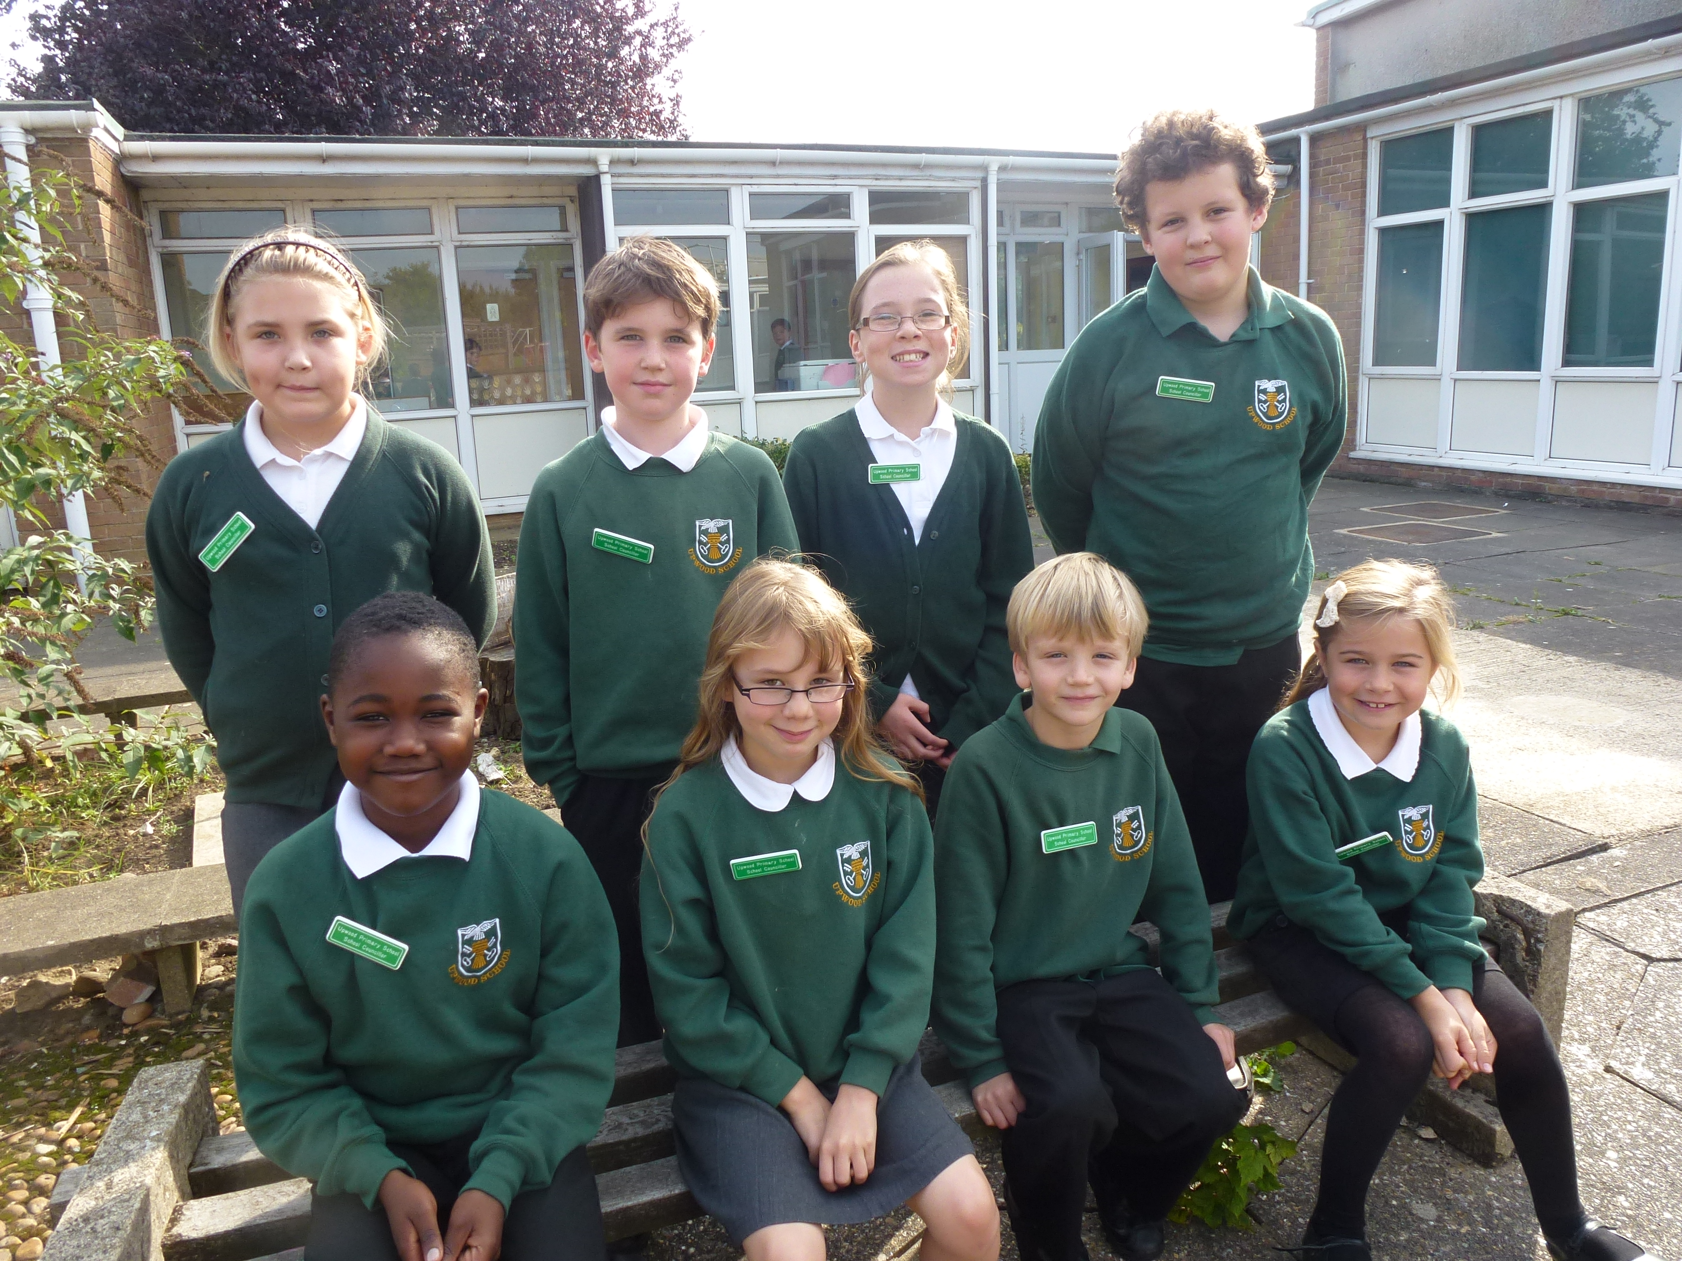
School Dress
We expect children to be tidy in appearance and to be suitably dressed for the variety of indoor and outdoor activities which they will pursue during the school day. We hope that all our parents/carers will support our view that every child in our school should follow the School Dress Code. We feel it enhances a feeling of pride, fosters a sense of belonging and provides a positive image of the school.
On a practical note, our Dress Code may assist parents/carers with preparation for school, as it eases the discussion and potential competition surrounding what to wear. We feel the School Dress Code is an attractive and versatile solution that offers value for money and still gives scope for individuality.
The Governing Body recommends the following School Dress Code:
WINTER
Boys | Girls
Trousers – black or grey  Shirt – white  School polo shirt – white/green  Pullover – dark green or grey  School Sweatshirt – dark green  School Fleece (dark green, outdoor use) | Skirt or Tunic – black or grey  Blouse – white  School polo shirt – white/green  Pullover or Cardigan – dark green or grey  School Sweatshirt – dark green  School Fleece (dark green, outdoor use)
SUMMER
Boys | Girls
Trousers or shorts – black or grey  Shirt – white  School polo shirt – white/green  Pullover – dark green or grey  School Sweatshirt – dark green  School Fleece (dark green, outdoor use) | Skirt or Tunic – black or grey  Blouse – white  School polo-shirt – white/green  Dress – green/white gingham check  Pullover or Cardigan – dark green or grey  School Sweatshirt – dark green  School Fleece (dark green, outdoor use)
PHYSICAL EDUCATION (Boys and Girls)
P.E./Games Kit |  | Swimming
Black shorts  White T-shirt |  | Trunks or costume  Towel  Poolside footwear
Drawstring bag for games kit

The following items are produced in the school colours and are decorated with an embroidered school badge. They are available from the School Office. A price list is also available.
- School Fleece (dark green)
- School Sweatshirt (dark green)
- School Sports Shirt (white)
- School T-Shirt (green or white)
All other items of school dress are available from the main High Street retailers.

Absence from School
Illness
If your child is absent from school due to illness please contact the School Office on the first day of non-attendance.

Holiday Requests
The Government brought in new legislation from 1st September 2013 regarding parental requests for leave of absence (including holiday absence). Amendments remove references to family holiday and extended leave as well as the statutory threshold of ten school days.

The amendments make clear that head teachers may not grant any leave of absence during term time unless there are exceptional circumstances, e.g.:
- If a parent, grandparent or other close relative is seriously/terminally ill and the holiday proposed is likely to be the last such holiday.
- If there has recently been a death or significant other trauma in the family and it is felt that an immediate holiday might help the child concerned better deal with the situation.
- If the holiday is a unique, one-off, never-to-be repeated occasion which can only take place at the time requested.
The financial factor of taking holidays during term time will not be taken as constituting an ‘exceptional circumstance.’

The governors recognise that regular attendance at school is essential for children to make progress. Even one or two day’s absence from school affects progress as children miss teaching input which is sequential.

If a parent/carer needs to request a leave of absence from school, the form can be accessed via the School’s website (‘Policies and Prospectus’ section): http://www.upwood.cambs.sch.uk/. Alternatively, for parents/carers without internet access, a copy of the form can be obtained from the School Office.

Schools are unable to grant leave of absence:
- If a child’s attendance record over the previous 20 week period is less than 95% - even if any previous absence was due to unavoidable causes such as illness.
- If the period of leave coincides with the start of term, or is near to, or coincides with tests, SATs or other significant events in the school calendar. (For this reason, the Governing Body at Upwood Primary School has agreed that no holiday requests in September and May will be authorised).

If leave is taken without authorisation, it will be recorded in the School’s attendance register as Unauthorised Absence (the same as truancy), and the matter will be referred to the School’s Education Welfare Officer.

Upwood Small to Tall
Upwood Small to Tall meets in a modular building, to the rear of the school site, and is run by its own independent Committee who ensure that childcare is reliable, safe and flexible for the families that use it. Children are supervised by qualified and experienced members of staff in a caring, relaxed and friendly atmosphere.
Pre-School
Available every weekday of term time for children aged 2 years 9 months to school entry age. Children’s learning is facilitated through a play-based curriculum and introduces children to routines and skills they will develop in their formal school life. School and pre-school staff work closely together and occasionally organise joint ventures. This close liaison encourages a smooth transition into Primary School.

Breakfast and After School Clubs
The Breakfast Club opens between 8.00am and 9.00am every weekday of term time. The After School Club, also open weekdays of term time, offers out of school provision from 3.30pm to 6.00pm. Both clubs are available to children aged 4-11 years who are attending Upwood Primary School. Clubs offer games, toys and fun activities for indoor and outdoor recreation.

Upwood Primary School Parent Teacher Association (PTA)
We are extremely fortunate at Upwood to have a very high degree of involvement and commitment from our community. Our Parent Teacher Association (PTA) is actively involved in a full programme of educational, social and fund raising activities, for both children and adults, from which the school benefits greatly.
Monies raised to date have enabled us to purchase computers, a sound system, raised play area, outside permanent play equipment, PE mats, Library books and numerous other items.
All parents/carers, teachers and friends are automatically members of our PTA and are kept informed via regular newsletters. The Annual General Meeting is normally held within the first two weeks of the Autumn Term, when the new committee is elected. Members can help in many ways and every contribution, regular or occasional, is always welcome and appreciated. Its’ broad membership base helps keep our PTA a stimulating and creative organisation.

CURRICULUM

Introduction to the National Curriculum
The National Curriculum is a framework covering the subjects and skills that all children have a right to learn. It is devised by the Government and implemented by the schools. The National Curriculum includes targets, or Levels, for each Stage of the Curriculum (see table below). These Levels measure your child’s progress in each subject and your child moves up through the Levels as they move through the school.
STRUCTURE OF THE NATIONAL CURRICULUM
Age | Stage | Year | Tests | Target Levels
3-4 | Foundation | Pre-School | N/A
4-5 | Foundation | Foundation | A Foundation Stage Profile is compiled for each child
5-6  6-7 | Key Stage 1 | Year 1  Year 2 | Teacher assessments in English and Maths | Level 2
7-8  8-9  9-10  10-11 | Key Stage 2 | Year 3  Year 4  Year 5  Year 6 | National tests/tasks in English and Maths | Level 4
11-12  12-13  13-14 | Key Stage 3 | Year 7  Year 8  Year 9 | National tests/tasks in English, Maths and Science | Level 5/6
14-15  15-16 | Key Stage 4 | Year 10  Year 11 | Some children take GCSEs  Most children take GCSEs or equivalent
Notes: Target Levels are applied at the end of each Key Stage.
Targets in each subject describe what children should be able to know and do. Level 2 is the target for 7 year olds and Level 4 is the target for 11 year olds.
The aim of the targets is to give a level that most children should have reached by a certain age. There will always be some children below and some beyond the target.
There are finer divisions within each Level, e.g. Level 2a, 2b and 2c. 2a is high, 2b is average and 2c is low.

It is important to remember that children develop at different rates. Some children may not reach the Level at the given age but will catch up later. Our assessment of your child’s progress is on-going and we are always happy to talk to you about any concerns as they arise.
The National Curriculum stipulates that all schools must teach a daily Literacy Hour, a daily Numeracy Hour and Physical Education every week. Each school can then decide how to organise its own curriculum to teach all the other subjects. The National Curriculum comprises ‘core’ and foundation subjects only. Core subjects are tested at Key Stage 2.
Core Subjects | English, Maths and Science
Foundation Subjects | Information and Communication Technology (ICT), Design and Technology, History, Geography, Art and Design, Music, Physical Education, Modern Foreign Languages (MFL)
Additional Subjects | Religious Education, Personal, Social and Health Education (PSHE)

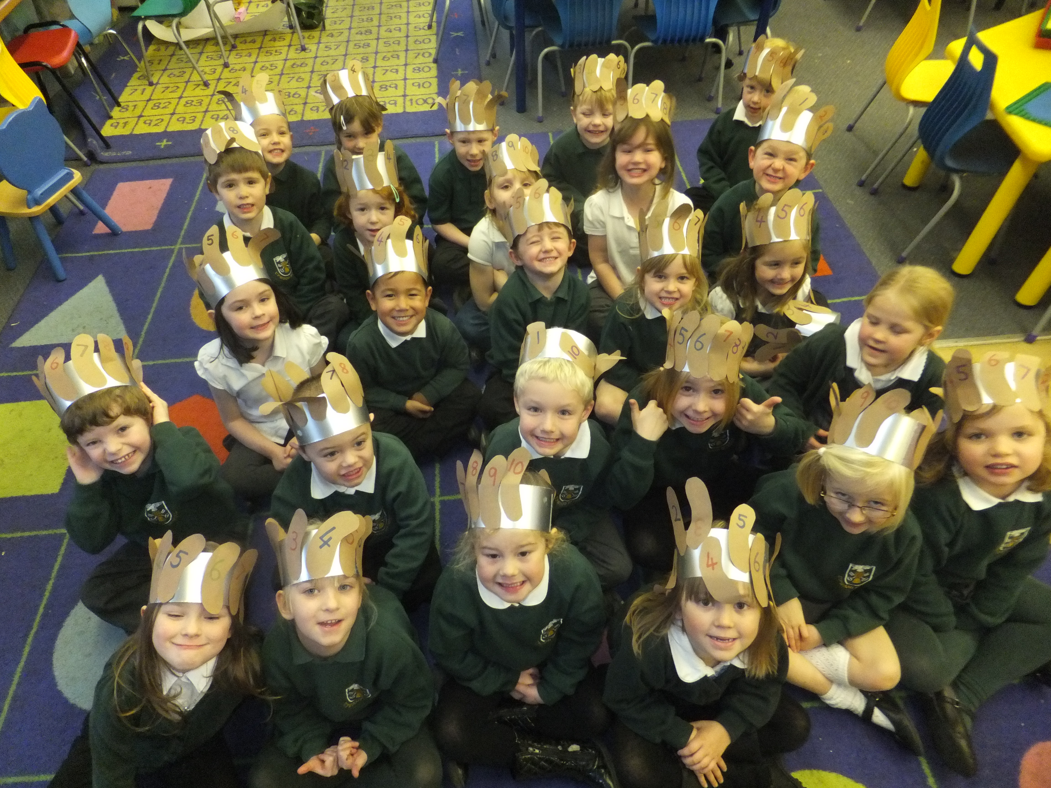
Foundation Stage
Our curriculum for the Foundation Stage encompasses the seven main areas of learning and development set out in the Statuary Framework for the Early Years Foundation Stage. All areas of learning and development are important:
- communication and language,
Numeracy in Foundation
- physical development,
- personal, social and emotional development,
- literacy,
- mathematics,
- understanding the world,
- expressive arts and design.
Each of these seven learning areas contain a number of Early Learning Goals which set out what most children are expected to achieve by the end of the Foundation Stage. There are no formal tests during this Stage. Assessments are made and recorded via adult observations. These records contribute to the Foundation Stage Profile which is a summary of each child’s attainments compiled at the end of the Foundation Stage and measured using the Early Learning Goals.
The Foundation Stage is the first step for a child beginning his or her school life and we appreciate what a big step this can be for parent/carer and child alike. Whilst the Foundation Stage has a strong emphasis on play and fun, activities are carefully structured to enable each child to develop particular skills and gain confidence in the new environment of school.
We understand the value of a caring and supportive atmosphere and within this create stimulating experiences to help children gain the basic skills to enable them to join Year 1 as confident and enthusiastic learners.

School Curriculum
We have developed a broad and balanced curriculum to challenge and stimulate all our pupils. We value creativity and imagination as an essential part of young children’s learning. Our curriculum is designed to enable your child to progress personally and academically, to optimise their potential and encourage their development as independent, confident and enthusiastic learners.

English
The development of good language skills is pivotal to a child’s personal and academic progress. At Upwood Primary School we create a language environment that is rich in opportunities for children to talk, listen, read and write with confidence and enthusiasm. In line with the Government’s renewed Primary Framework for literacy we apply systematic high-quality phonics work across our curriculum. The teaching of synthetic phonics is a crucial element of the reading and writing process. The additional practice that children can get at home is invaluable and to support our Key Stage 1 parents/carers we have an evening workshop to provide guidance on reading and phonics practice at home.

Speaking and Listening
We believe that speaking and listening skills are essential to any language programme. A wide and varied range of activities, both formal and informal, are provided to stimulate and encourage children to practice these vital skills with adults and with other children.
We encourage children to express themselves with confidence and to be sensitive to the views of others. Skills are practiced constantly and developed through conversation, discussion, message giving and drama and so serve as a key skill throughout all school activities. With visitors to school and excursions outside of school these skills are also practiced with people and in situations outside the school environment.

Reading
Good reading skills provide a life-long foundation for learning. While learning to read we also emphasise the importance of understanding the meaning of text. Together with developing basic reading skills we foster a positive attitude to reading and encourage our children to read for pleasure and adventure. We consider our library to be a valuable resource in this endeavour and regular times are scheduled for each class to use the library, in addition to the reading materials available within each classroom. In March each year we celebrate the unique contribution of books to our learning and life experiences by participating in World Book Day.
Building on their oral skills, children are taught synthetic phonics – this is an approach to teaching of reading in which the sounds (phonemes) associated with particular letters are pronounced in isolation and blended together (synthesised). For example, children are taught to take a word, such as ‘cat’ apart into its three letters, pronounce a sound (phoneme) for each letter in turn and blend the sounds together to form a word. As their knowledge of the alphabet develops children are taught reading through guided reading sessions as part of a group activity. They also learn to recognise the pattern of simple groups of letters and identify words. The children also learn about sentence construction and punctuation.
Our reading system is called Book Banding, which organises reading material into different colour bands. Each band contains fiction and non-fiction in a range of ability with some books being challenging and some a little easier. Each colour band is progressively more challenging. The Book Bands system is all about empowering children to read independently. They are able to choose material from within their colour band, rather than following a set scheme. The bands enable children to learn and use the four searchlights for reading: phonics, knowledge of context, grammatical knowledge and word recognition.
We encourage all our parents/carers to continue reading practice at home as it is a valuable support for young readers. Parents/carers can become involved through ‘paired reading’ where they and their child share books by reading together. Those parents/carers who would like to help with reading activities in class are always very welcome.

Writing
Running alongside the teaching of reading is the development of writing skills. It is our aim to enable our children to express their thoughts, feelings, knowledge and observations creatively, accurately and with confidence.
The children experience writing in many forms and for as many purposes as possible, including letter writing, reporting and recording, poetry and prose. Accurate written communication is important for progression in all subjects. Focus is on developing the basic skills of spelling, handwriting, grammar and punctuation.
As in reading, children are taught synthetic phonics to assist writing development. Synthetic phonics for writing reverses the sequence: children are taught to say the word they wish to write, segment it into its sounds (phonemes), say them in turn and write a letter (grapheme) for each sound in turn to produce the written word.
Shared writing is the principal means of teaching writing and enables teachers to:
- work with the whole class, to model, explore and discuss the choices writers make at the point of writing.
- make the links between reading and writing explicit by reading and investigating how writers have used language to achieve particular effects and by using written texts as models for writing.
- scaffold some aspects of writing, e.g. the spelling and handwriting, to enable children to concentrate on how to compose their writing, e.g. through the choice of words or phrases and ways of constructing sentences to achieve particular purposes or effects.
- focus on particular aspects of the writing process, such as planning, drafting and revising.
- provide an essential step towards independent writing by helping children to understand and apply specific skills and strategies.
Guided writing is an important element of teaching as exemplified in the Primary Framework and is a key step between whole-class teaching and independent writing. It is during the guided writing session that children are supported to improve their writing and to work with increasing independence. During guided writing, teachers work with groups of children according to their current targets or specific needs.

Mathematics
The Numeracy Hour is a fundamental part of our mathematics curriculum which aims to give children a thorough understanding of and competence with key mathematical skills using oral, mental and practical activities.
We recognise that a solid foundation is essential for future learning, so as children progress in mathematics, we encourage them to use their acquired skills and knowledge in a variety of problem solving and investigative activities. A broad range of topics are covered, encompassing numbers, data handling, shape and space and the five aspects of measure - length, weight, time, volume and capacity.

Science
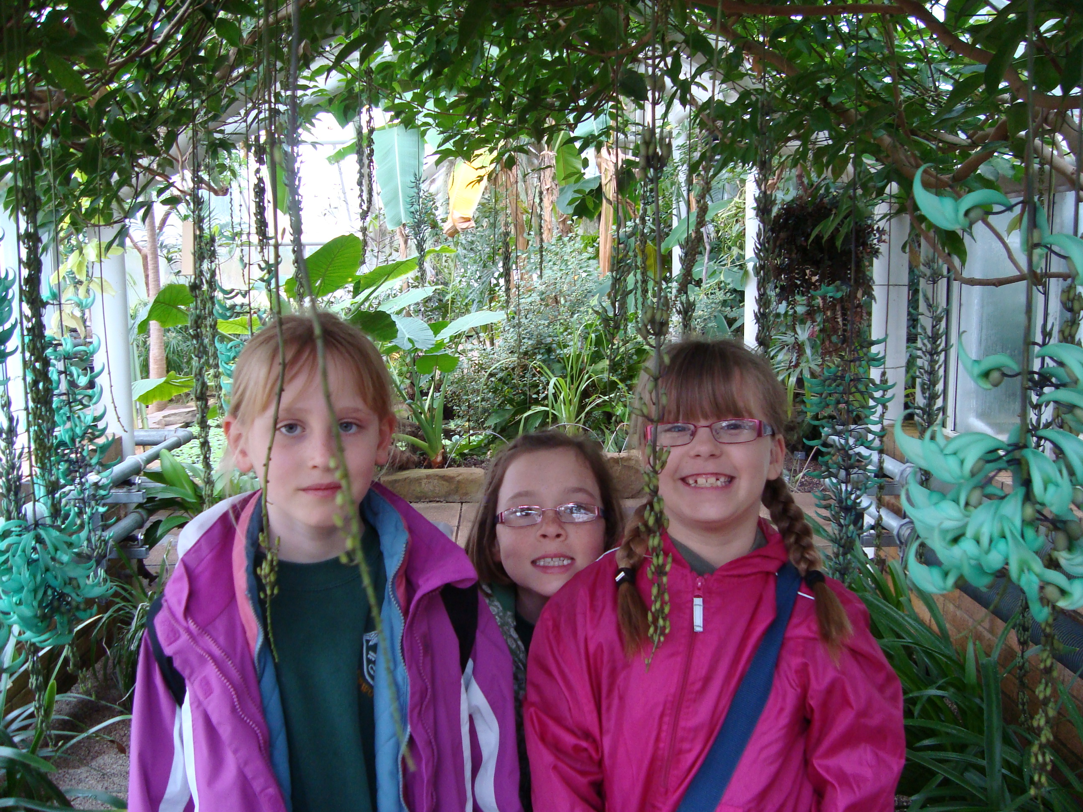
Bringing Science to life
Science investigates our world and children derive great enjoyment from this exploration. Our science curriculum expands children’s natural curiosity about the world around them. Following the National Curriculum our children look at and explore:
- Life processes and living things (such as familiar plants and animals).
- Materials and their properties (such as wood, paper, rock).
- Physical processes (simple ideas in physics taught through experiences with electricity, forces, light and sounds).
Working in these three areas children are introduced to the concept of scientific enquiry. By investigating these everyday materials and processes they learn to challenge, experiment, compare, evaluate, record and explain aspects of the world around them. Their scientific studies also develop research methods, computer skills and communication skills including drawing and the use of scientific language and tools.

ICT (Information and Communication Technology)
Modern technology is changing the way we live, work and play. Children need to develop the skills and confidence to cope with the ever-changing world of computers. Through the ICT curriculum we provide the basic skills to enable our children to become competent computer users.
Children soon become familiar with the keyboard, learn what a computer can do and also the role it plays in the outside world. Key skills such as word-processing, collecting and integrating data and control technology are taught. Computers are also a resource used by children for collaborative work on problem solving activities and experimenting with educational games. In this way ICT is integrated across the whole school curriculum to support and enhance learning opportunities in many areas.
As part of the school’s ICT curriculum children are offered supervised access to the Internet. The class teacher will direct the use of the Internet during lesson time. Internet access for our school is provided and managed by Cambridgeshire County Council. In addition, we have procedures in place to facilitate safe internet use and these are detailed in our ‘Internet Policy’.
To develop practices for responsible Internet use staff, parents/carers and pupils sign a declaration to uphold the school’s rules for responsible internet use. In accordance with our ‘Internet Policy’ document, the school requires a signed Internet Access Permission Form from parents/carers before access can be given in class.

Design Technology
What makes a good design? Why is one material better than another? Our Design Technology lessons are aimed at giving children a practical opportunity to investigate how and why familiar objects work. They work collaboratively to seek solutions to many everyday problems. Design work stimulates inventive thinking and creative problem-solving skills. Practical skills and dexterity are developed through making up the designs.
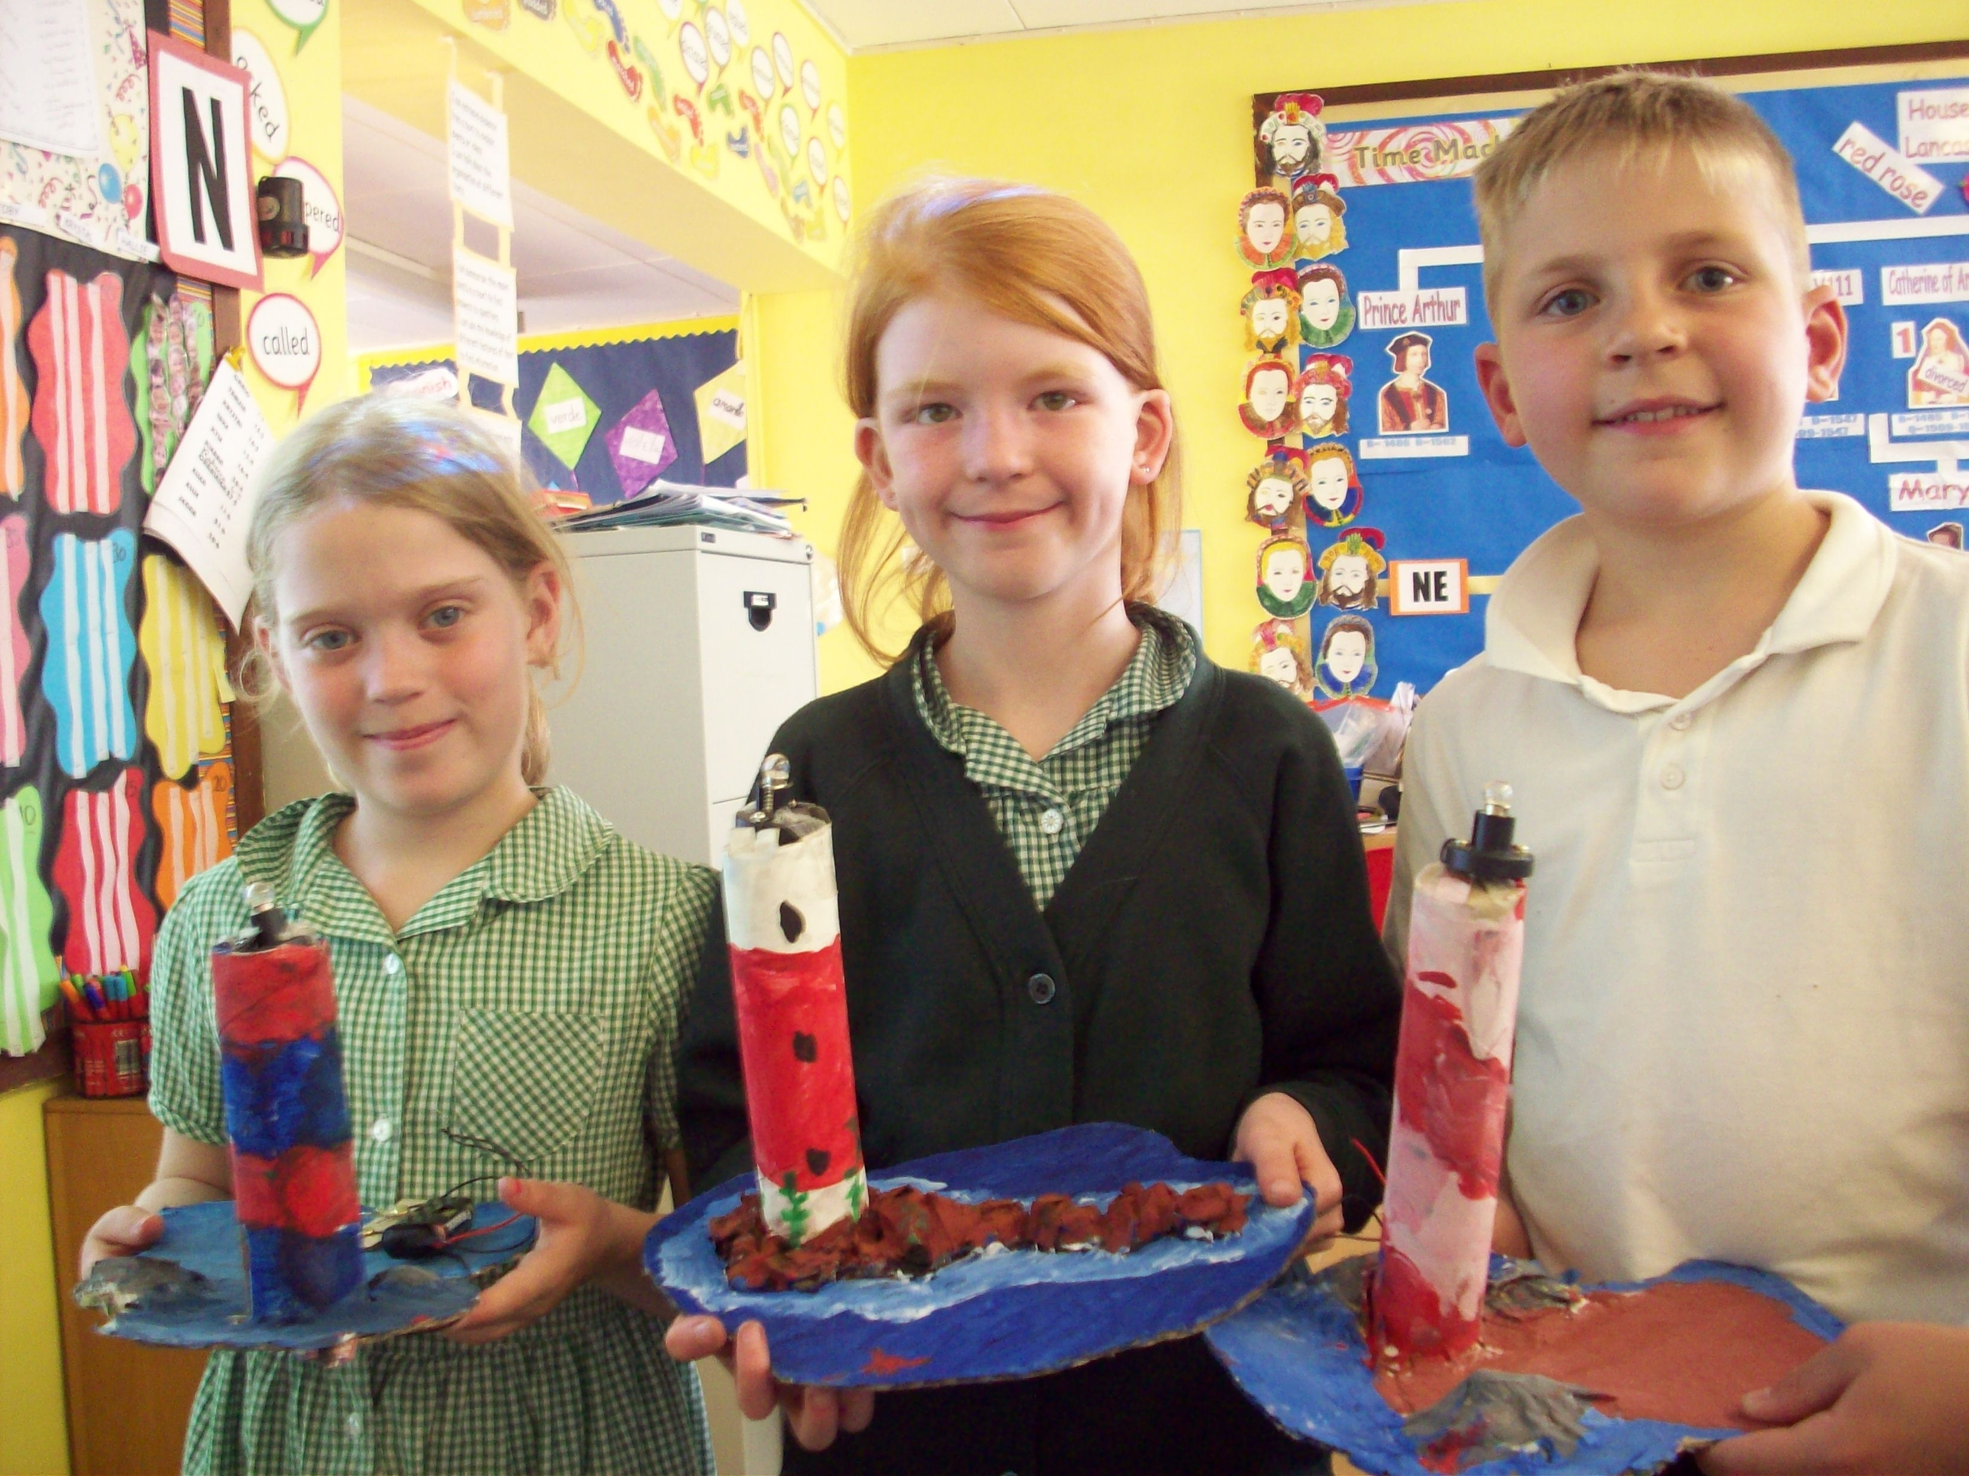
Making Lighthouses
A Design Technology week is held each term. This is a stimulating school-wide activity that optimises teaching time and use of materials.

History
In studying History, we introduce children to an unfamiliar yet important world – the past. Where do I come from? How did I get here? Investigating the past helps children shed light on these big questions. Exploring some key lives and events from British history and the wider world demonstrates the chronological order of time and helps to locate the current world in context. Skills are developed through seeking information, weighing evidence, reaching and presenting conclusions.
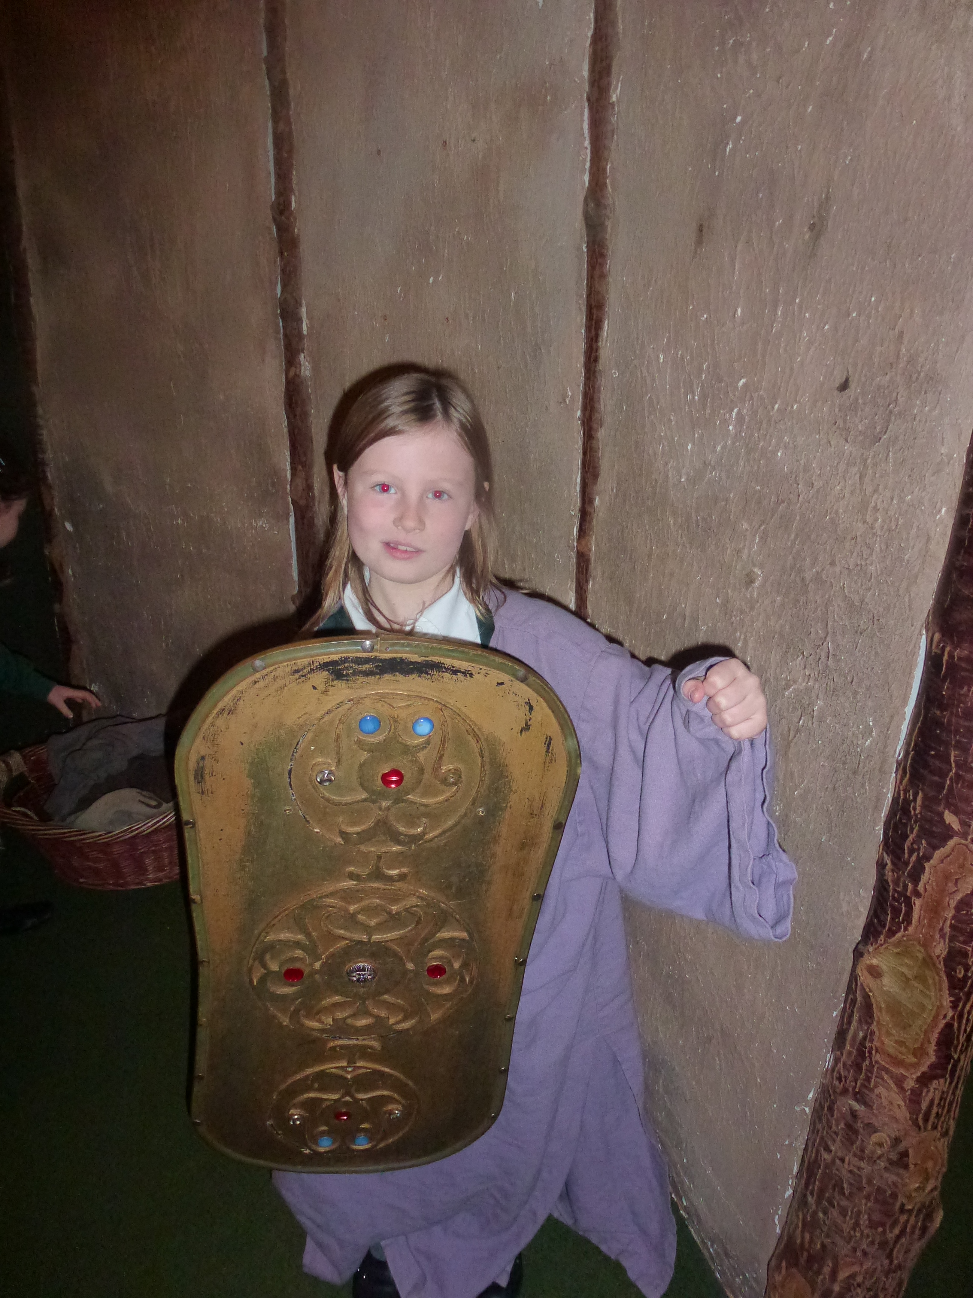
Castle Visit

Geography
The links between the way we live and the environment around us are central to the teaching of Geography. Comparisons are made between our local area and a contrasting environment, either elsewhere in the United Kingdom or overseas. Work in Geography introduces children to abstract concepts such as maps and plans.

Art and Design
We believe children’s imagination is enriched through artistic expression. At Upwood Primary School our Art and Design Curriculum encourages children to develop ideas and express themselves creatively.
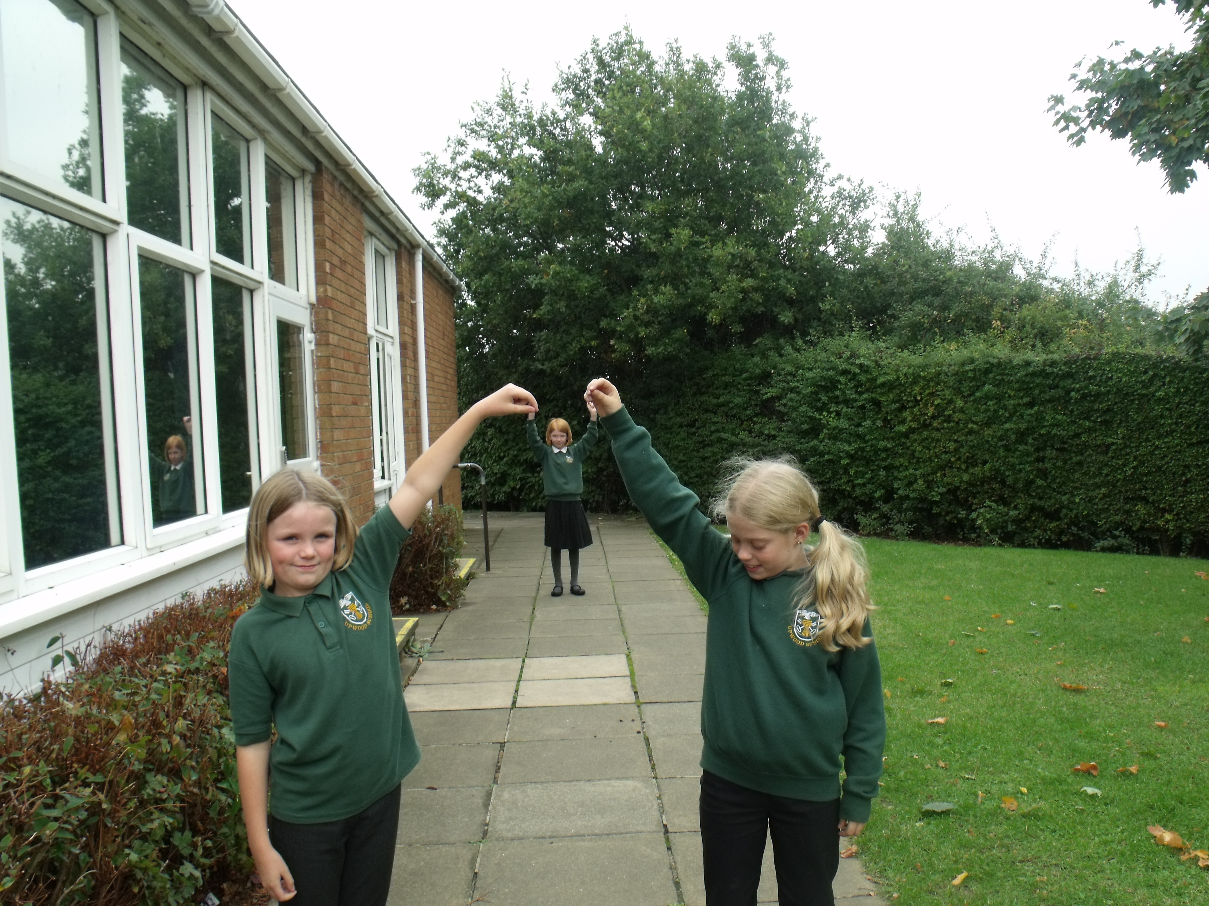
Playing with Perspective

They learn the skills and processes of modelling, printing, observational drawing, sketching, painting and collage, through handling and exploring a simple range of materials such as paint, clay, pastels, paper and fabric. Children learn how to review their own work and that of others, developing critical, observational and communication skills.
Art is a medium for experimenting with our perceptions of the world around us. As well as developing their own artistic awareness we explore the contribution to the wider world of artists past and present. Occasional visits to school by local artists provide additional inspiration for our pupils. Art and Design activities develop a range of practical, social and intellectual skills that enhance learning experiences across the wider curriculum.

Music and Drama
Music appears throughout our school and across the curriculum with formal lessons, assemblies, plays and concerts. Creating and playing music together helps children explore and express their thoughts and feelings. Learning songs from the past, or from different parts of the world, allows children to connect in a familiar way to otherwise unfamiliar experiences. Opportunities to listen to music encourage attention and concentration skills. Such skills are helpful to a child throughout their school career.
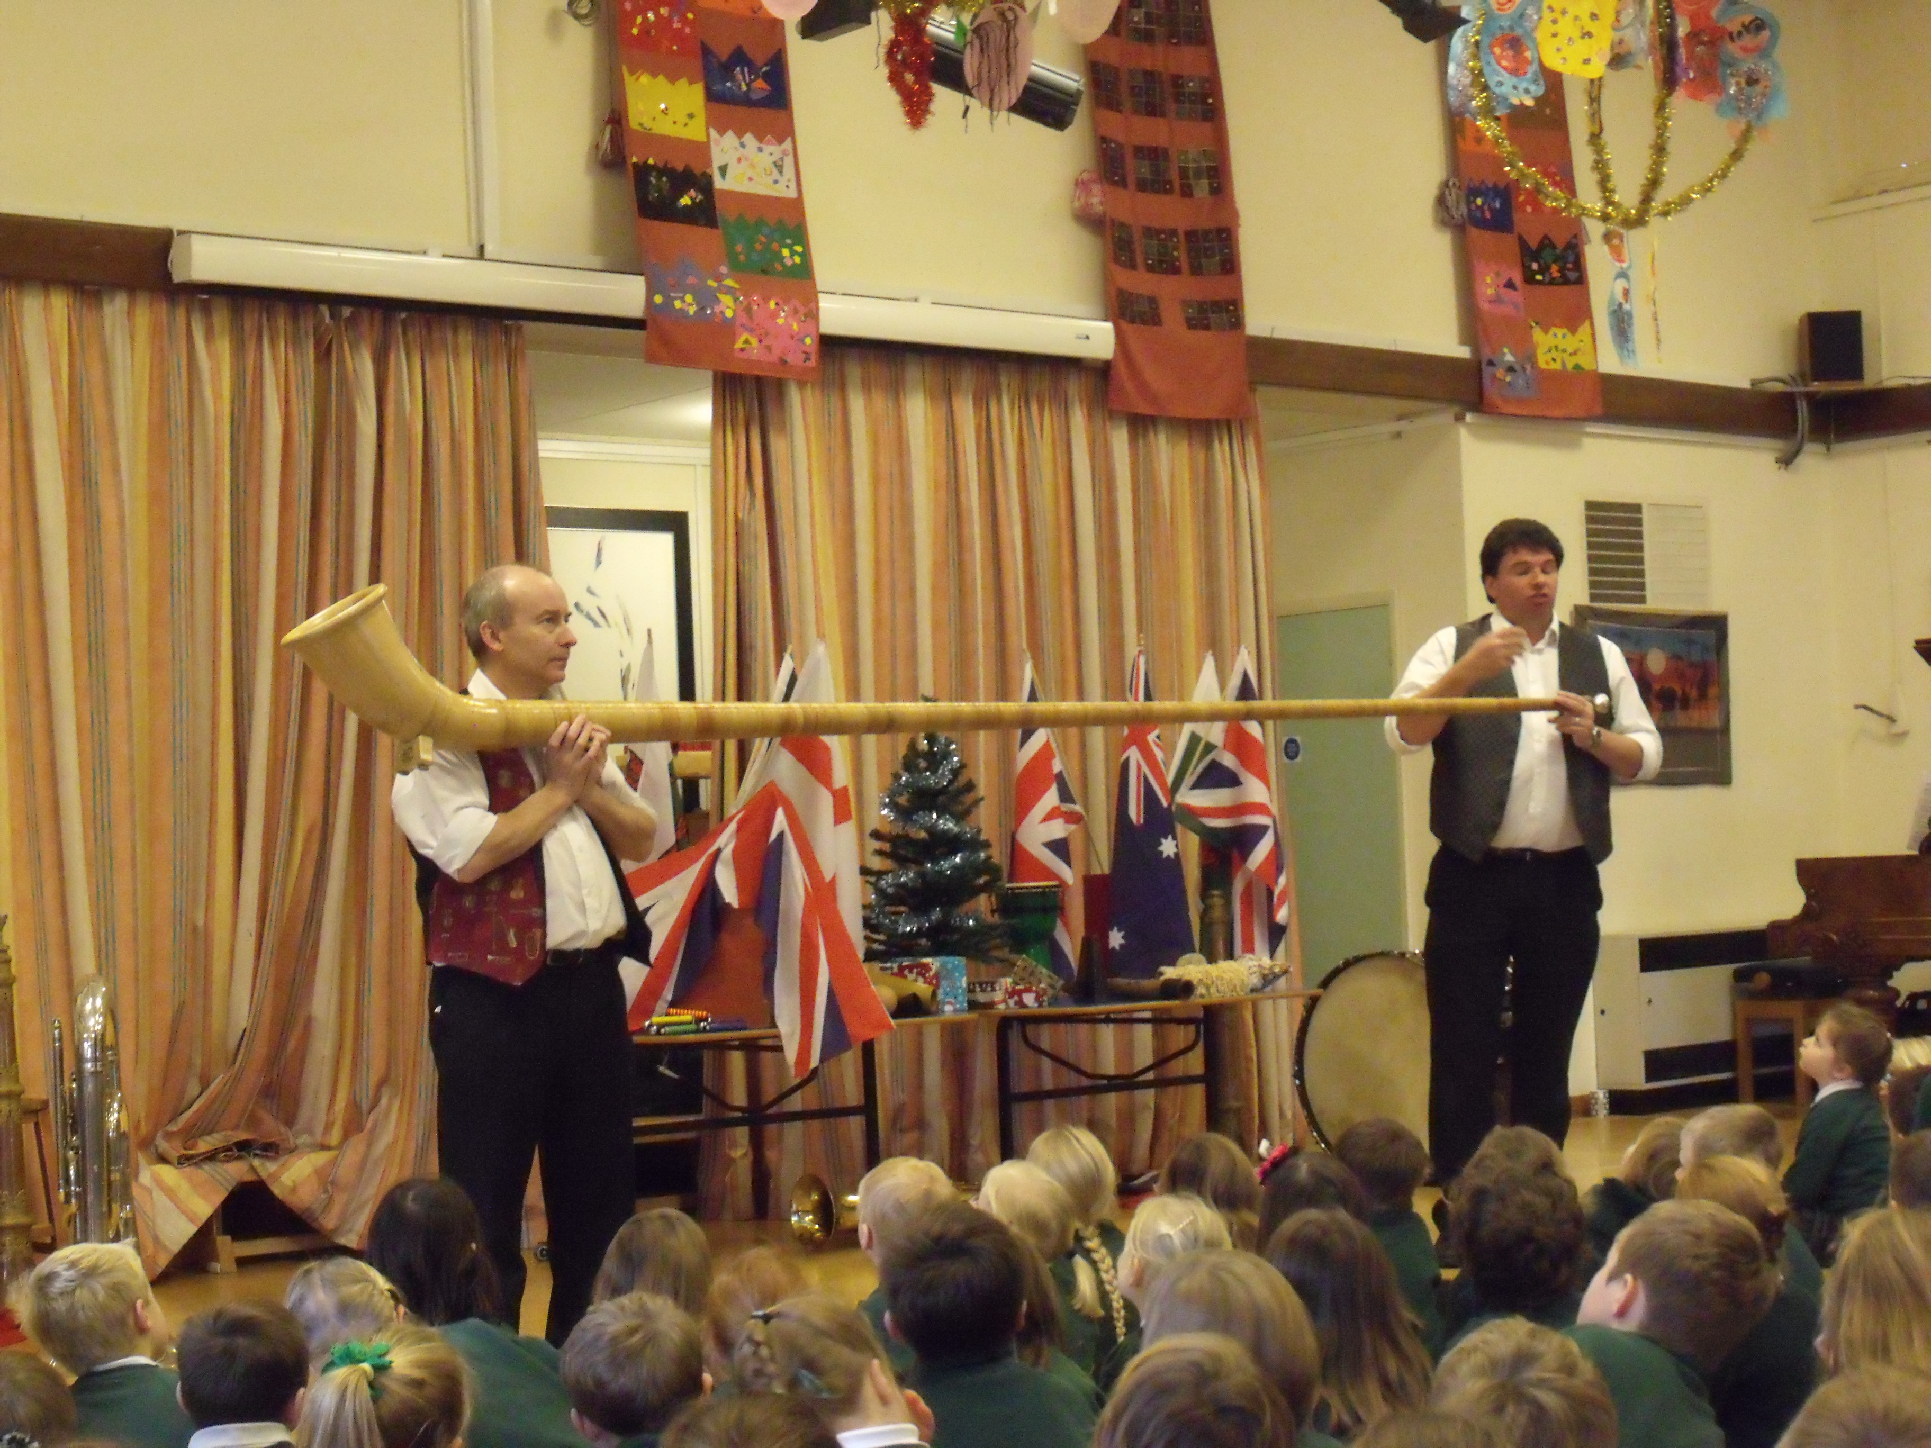
A Visit from the Travelling Tuba
All our children are involved in the activities of singing, playing percussion instruments, listening to and creating music.
Drama gives children a valuable opportunity to explore ideas creatively and imaginatively. In this way they may discover more about themselves and others and come to a deeper understanding of topics that are covered in different areas of the curriculum.
Our music and drama activities often culminate in a production before part of the school or for the wider community. The children work extremely hard, achieving very high standards and thoroughly enjoy the excitement of performing before an audience. These performances offer valuable opportunities for whole-school activities.
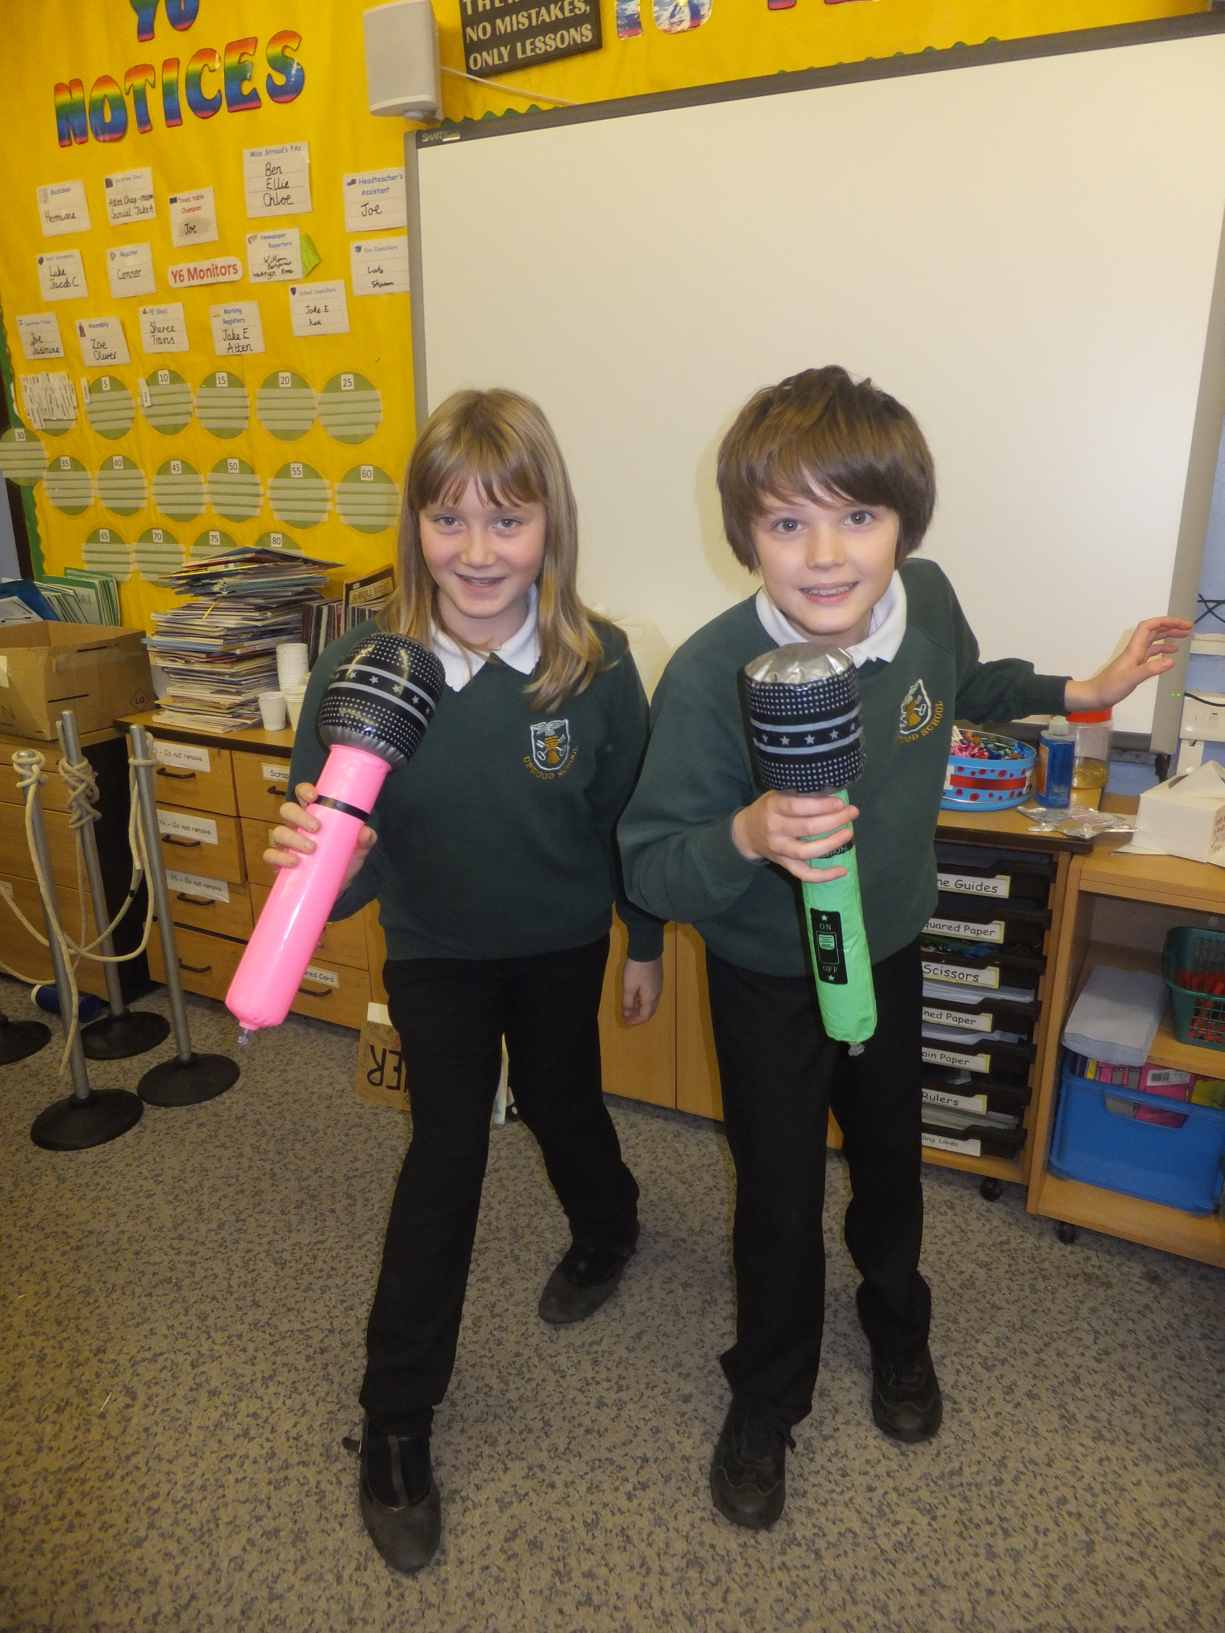
Practising for a Performance

Religious Education
Our Religious Education curriculum is in accordance with the Cambridgeshire Agreed Syllabus for Religious Education. We aim to teach our children about beliefs and values that reflect the predominantly Christian traditions of this country. We feel it is important to also reflect in our school that ours is a modern multi-cultural society. We expect our staff and pupils to respect the beliefs and practices of others and encourage the development of sensitive attitudes towards each other’s beliefs.

Collective Worship and Assemblies

School assemblies are held each day of the week. Children play an active part in collective worship and assemblies. These occasions encourage the community spirit that underlines the ethos of our school. Our assemblies often include guests from the wider community. Our Friday afternoon assemblies include opportunities to celebrate the special achievements and certificates awarded across the whole school.
It is a parent’s/carer’s right to withdraw their child from Religious Education and/or collective worship. If you should wish to remove your child from either or both of these activities please notify the Head Teacher in writing. We will then discuss with you suitable, alternative arrangements for your child at these times.

Physical Education

Through physical activity children learn much about the capabilities of their own bodies. They learn how to prepare for and recover from exercise and what happens to their body when they are physically active. This is an important foundation to help them lead active, healthy lives as they grow up.
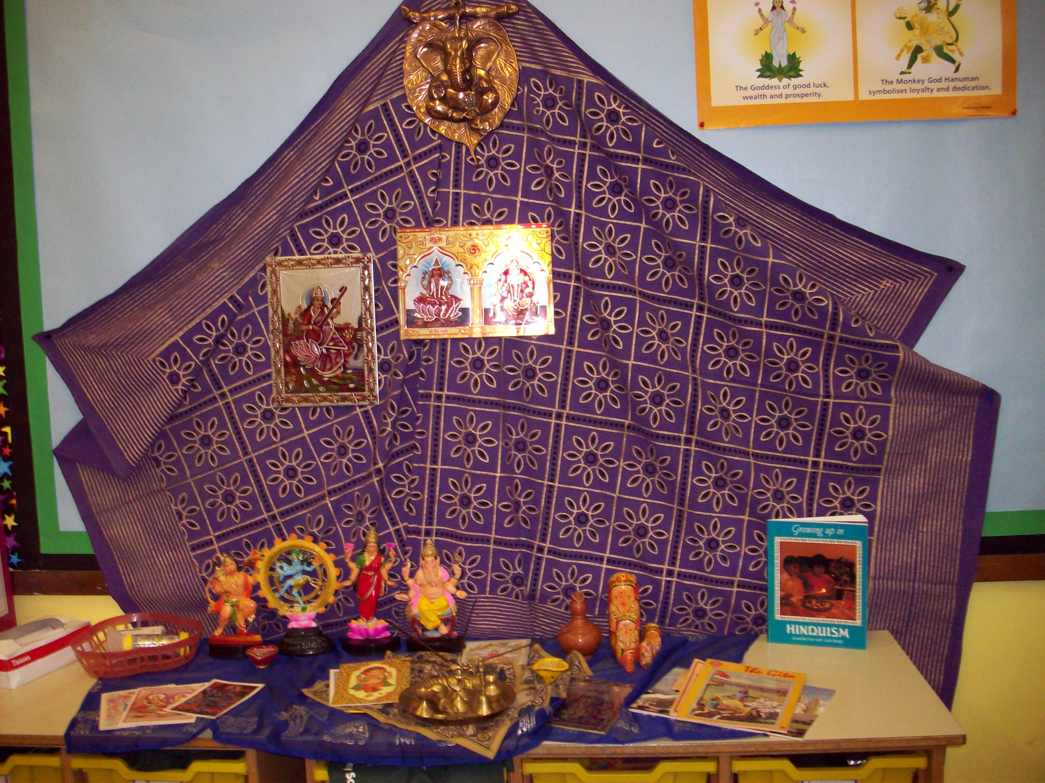
Beginning with simple skills such as throwing and catching, running and skipping, they learn to work with a variety of apparatus including beanbags, bats, balls, ropes and hockey sticks. Through sports, games and dance children develop balance, co-ordination and rhythm. They learn how to compete individually and how to work in teams.
With growing confidence and skill they work co-operatively in a number of team situations that ultimately include competing in inter-school events. Activities include: football, High 5’s, athletics and cricket.

Personal, Social and Health Education and Citizenship
Finding out about Divali
Personal, Social and Health Education (PSHE) promotes pupils’ personal, social and emotional development, as well as their health and well-being. Our PSHE curriculum is designed to help give our children the knowledge and skills they need to lead confident, healthy and independent lives. It aims to help them understand how they are developing personally and socially, and explores many of the moral, social and cultural issues that are part of growing up.
We are committed to the health and safety of all the members of our school community.

Sex Education Policy
Sex Education is included as an integral part of the school health education programme. Children in Key Stage 2 will study the details of human reproduction. Parents/carers will be invited to a meeting prior to the programme being undertaken, so that they can be involved and prepared for the issues and questions that may arise at home. They will be able to see the materials used, including a video, be informed about the contribution of outside speakers and see a copy of the school’s current ‘Sex Education Policy’. It is a parent’s/carer’s right to withdraw their child from sex education.

Drugs Education Policy
As part of our care for the welfare of pupils we aim to educate and inform all our pupils on the consequences of drug use and misuse. We recognise how important it is to deliver this curriculum within the framework of a caring environment. We believe that parents/carers and school should work in partnership and share responsibility for educating our young people about this important issue. A copy of our full ‘Drugs Education Policy’ is available.

Special Educational Needs
Children with exceptional abilities and talents, children with physical disabilities and children with learning difficulties, have special and particular needs. In order for them to realise their full potential, these must be recognised and met.
We are fortunate to be able to call upon specialist support that includes speech therapists and an Educational Psychologist. The appropriate specialist works closely with the child and their teacher, selecting appropriate resources and materials to be used and devising specified programmes.
Progress is monitored constantly and alterations to the programme are made if, and when, necessary. The children are actively encouraged to record their successes, and to take pride in their achievements and the goals reached.
Parents/carers are closely involved at all times and are encouraged to take an active part in supporting their child.
A member of staff is appointed as the Special Educational Needs Co-ordinator (SENCo) to ensure appropriate measures are in place and to co-ordinate action and monitoring across the whole school. Our full ‘Special Educational Needs Policy’ is available.

Gifted and Talented
A separate register for pupils identified as Gifted and/or Talented is maintained and monitored by the Head and Deputy Head Teachers. Pupils are identified as ‘Gifted’ in English, Maths and Science, and/or identified as ‘Talented’ in Music, Art and Physical Education, in the main.

Abbey School Cluster Area (ASCA)
We are fortunate to be part of ASCA, a community of 10 schools comprising infant, junior, primary and one secondary school within the Ramsey area. The cluster is committed to working collaboratively to create purposeful learning activities for all our children. Being part of ASCA means we can benefit from shared knowledge and experience to respond to both national and local initiatives within education.
Working collectively we can promote continuity across all phases of education and ensure a smooth and positive transition between Key Stages and schools. We aim to provide additional opportunities for pupils over and above those provided by each school. For example, every term, gifted and talented workshops are planned for children in each school to participate in; tailored to meeting the needs of our more able learners. These are much enjoyed and cover both Key Stages. ASCA also plans collaborative teaching projects, most recently this has focused on the development of the outdoor curriculum.

Assessment and Testing
Children are regularly assessed to identify their strengths and weaknesses and to plan for the subsequent stages in their education. This process begins in the Foundation class with the Foundation Stage Profile. At the end of Year 2 (Key Stage 1) and Year 6 (Key Stage 2) the children undertake Standard Assessment Tests (SATs) as required by the National Curriculum. This assessment measures their progress through the prescribed levels specified in each subject area.
Our staff use a variety of approaches to facilitate their understanding of each pupil’s progress. They make observations, listen formally and informally and use a child’s recording of their task as evidence. This will include written work, construction, reading, group or class discussion, models, graphical representations, self-assessment, diagrammatic, display work and computer generation.

Homework
Homework is any work or activities which pupils are asked to do outside lesson time, either on their own or with parents/carers. One of the most valuable areas in which our children can be helped at home is reading.
The purposes of homework changes as the children get older. Therefore at Key Stage 1 the emphasis is on developing a partnership with parents/carers and involving them actively in their children’s learning. At this stage the children will be working on key skills.
As children get older they will become more independent and develop more skills in the three core curriculum subjects of English, Maths and Science. By the end of Key Stage 2 the homework will cover a wider range of tasks and the children should be in the habit of devoting regular periods of time to study on their own. Year 6 pupils will be expected to keep a homework diary. Our full ‘Homework Policy’ is available.

Educational and Residential Visits
Visits of various kinds are an important part of our school year. They fall into two main categories. Firstly, there are those that are directly linked with on-going work where the objective is to bring firsthand experience to an area of study. These can be visits to specific places of interest, or can involve groups visiting the school, for example: African drummers and dancers. Secondly, there are residential visits. These extend the children’s horizons, develop their self-confidence and help them to build relationships in surroundings that are very different from those at school.
Our Year 3 and Year 4 children enjoy a residential stay.
Our Year 5 and Year 6 pupils enjoy a week’s stay each year in a location such as the Derbyshire Peaks, North Yorkshire or the Isle of Wight.

The Funding of Visits
The 1988 Education Act states that charges may not be levied for activities organised by the school such as day trips and residential visits. The Act specifically states that any activity that takes place in school time, or mainly in school time, must be free - except for the cost of board and lodging. There is no restriction on requesting voluntary contributions.
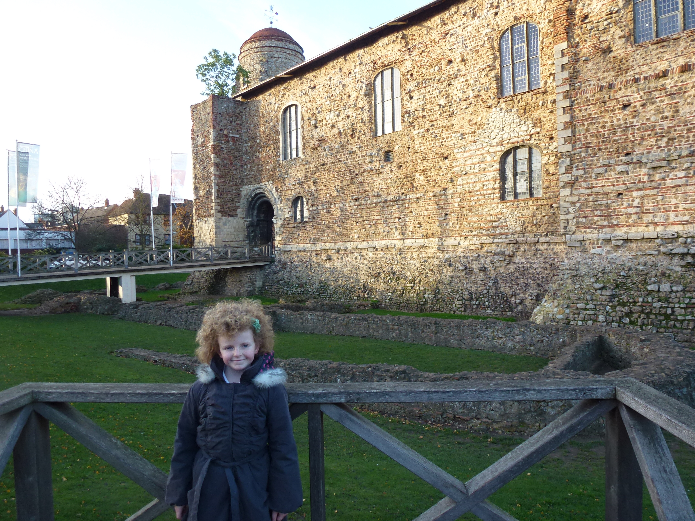
At the Castle
Throughout the school year the children are involved in a number of visits that, although not essential, are both an enjoyable and an enriching part of their education. The school does not receive separate funds to provide these excursions. In planning these activities we make every effort to minimise the costs involved as such trips can only take place with the understanding and voluntary support of our parental community.
Our policy is to send a letter to parents/carers outlining an activity and the level of voluntary contribution necessary to make the activity self-financing. In the exceptional circumstances of insufficient support being given, the school reserves the right to cancel the proposed activity and refund any contributions already received.
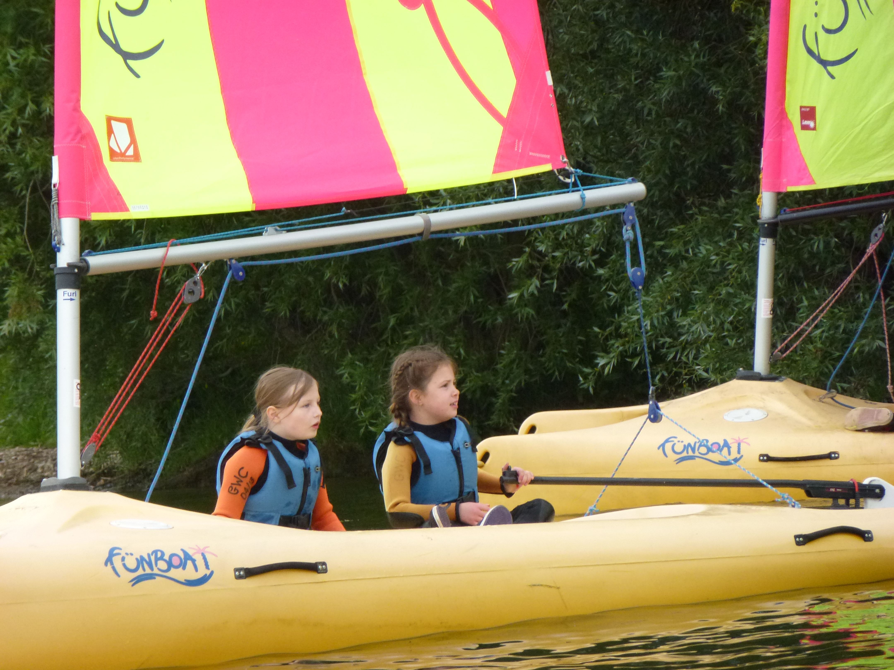
We believe that the experiences offered by these extra activities are invaluable and reassure you that no child will be excluded from an activity if their family cannot afford to pay the voluntary contribution.

COMMUNICATION WITH PARENTS/carers

Keeping In Contact
We value developing a close liaison between our school and each parent/carer as this enables us to work together effectively. We encourage any queries or concerns to be dealt with as they arise and parents/carers are always welcome to discuss these with the class teacher at the end of the school day.
From time to time it may be necessary to discuss an issue with the Head Teacher and arrangements to do this are made through the School Office. If the Head Teacher is not available a mutually convenient appointment for the earliest possible opportunity will be made.

School Policy Documents
Copies of relevant School Policy Documents are normally accessible via the School Website. However, maintaining the Website may mean that access is restricted from time to time. If required, hard copies of School Policy Documents can be obtained from the School Office.

Reports and Consultation Evenings
Parents/carers are invited to attend a Consultation Meeting during the Autumn Term. This is an opportunity to meet with the class teacher to discuss both the academic and social development of your child. A further opportunity to review progress and to set targets for the remainder of the academic year is offered with a second parent/carer Consultation Meeting in the Spring Term.
In the Summer Term we produce an Annual Report summarising your child’s progress and achievements over the full academic year. After receipt of this written report you are welcome to request a further meeting with the class teacher should you wish to do so.
Residential Trip to Grafham

Home-School Agreement
Our Home-School Agreement underpins our belief that children achieve more when school and parent/carer work together. This document reflects our school values and outlines the responsibilities of the school, the child and the parent/carer. We feel that in signing the Agreement all three parties demonstrate their commitment to working together. A copy of the Home-School Agreement is included in the New Intake Pack for new parents/carers.

Newsletters and Notices
Our Head Teacher issues a Monthly Newsletter to all parents/carers. This will cover a range of information and deals with activities across the whole school. Parents/carers will also receive letters and notices from the School Office, teaching staff and the Head Teacher on issues specific to their child or child’s Key Stage group. This includes a termly newsletter from each key stage.

E-Communication
The increasing use of computer technology allows us to disseminate information electronically. There are two distinct forms of electronic communication that we use; the school website and ParentMail.

School Website (http://www.upwood.cambs.sch.uk)
Our school website currently acts as an electronic notice-board, containing general school information, and a document library for those key documents that parents/carers may require access to. The website is under constant development.

ParentMail
ParentMail is a web-based e-mail service that we subscribe to. The service allows us to send messages straight to your computer’s mailbox, providing a fast and direct delivery. It is particularly useful for general school notices, dates and announcements. For security reasons we do not send messages about individual pupils. There is no charge to parents/carers for using this service. We encourage all our parents/carers to join this service should they wish to do so.
Developing our use of electronic communication has several benefits:
- efficient use of staff time by reducing the amount of paper copies required,
- saving money by reducing staff time and paper costs,
- responsible use of resources,
- access to school information at a time to suit you,
- direct mail between the school and parent/carer.
Whilst there are benefits to these systems we appreciate that not everybody can, or wishes, to use them. We will always provide hard copies of any information required and will always use the most appropriate method to communicate with parents/carers.

Freedom of Information Act (FOIA)
The Freedom of Information Act 2000, which came into force fully from 1 January 2005, provides a legal right for any person to ask a school for access to information that it holds. Although the Act presumes openness it recognises the need to protect sensitive information in certain circumstances and provides for exemptions.
One of the aims of the Act is that public authorities, including all maintained schools, should be clear and proactive about the information they will make public. Upwood Primary School has compiled its ‘Freedom of Information Policy’ in compliance with the Freedom of Information Act and a full copy is available. In summary our Policy covers:
- the classes of information which we publish or intend to publish;
- the manner in which the information will be published, and;
- whether the information is available free of charge or on payment.
Our Policy applies to information already published and information which is to be published in the future. The classes of information that we undertake to make available are organised into four broad topic areas:
- School Prospectus – information published in the school prospectus.
- Governors’ Documents – information published in the Governors Annual Report and in other governing body documents.
- Pupils & Curriculum – information about policies that relate to pupils and the school curriculum.
- School Policies and other information related to the school - information about policies that relate to the school in general.

Complaints Procedure
Our school is committed to developing a strong sense of partnership with parents/carers and other members of the local community. This helps to provide a good basis for understanding and resolution when things appear to go wrong.
A copy of our ‘School Complaints Policy’ document can be obtained from the School Office.
Our Policy describes the procedure to be followed when complaints are made by parents/carers and others about the conduct of the school or the actions of any member of our staff. The procedure excludes complaints relating to the school’s delivery of the National Curriculum. The procedure for curriculum complaints is summarised in the leaflet ‘Complaints about the School Curriculum’, which has been written specifically for governors and parents/carers. Copies of this are available to parents/carers and governors from the School Office.
The complaints procedure has three distinct stages:
- Informal stage: e.g. discussion between parent/carer and Deputy Head Teacher/Head Teacher. We very much hope that most complaints can be resolved at this stage.
- Formal complaint to the Governing Body of the School.
- Formal complaint to the Local Authority (LA).
Our main aim throughout any complaint is to resolve the matter as quickly and effectively as possible, to everybody's satisfaction.

HEALTH AND WELFARE

Health Care
The Local Authority provides a range of health related services for schools to advise parents/carers, children and teachers on any health problems that may affect a child’s progress at school.
During your child’s time at Upwood she or he may be seen by the School Doctor and School Nurse. These health visits include height and weight checks and vision and hearing tests. When such a visit is pending we will write to you in advance, notifying you of the date, time and purpose of the visit and inviting you and your child to attend. No examinations will be carried out without your permission.
Each school has a named School Nurse, who is a Registered Nurse, with further specialised training.
The health services provided via the school are supplementary to your family services and are not intended to replace them.

First Aid
Basic First Aid is available in School. We have staff members who are Local Authority qualified with current four-day or one-day First Aid Certificates. Any child who becomes unwell or who is injured during the school day will be cared for by one of our qualified First Aiders.
Any serious accident, or sickness, is referred to the Head Teacher and parents/carers are informed accordingly. If we consider that hospital treatment is necessary we will inform you immediately so that you may accompany your child to hospital.
It is essential that we are kept up to date with contact details. In the event that we are unable to contact you we will act, in the best interests of the child, on your behalf.

Medicines
Our procedures for handling medicines within School are drawn up in accordance with the guidelines provided by the Department for Children, Schools and Families and are regularly reviewed. We are willing to offer this care should it be required. However, First Aiders are not obligated to do so and may refuse to administer a medication if they are concerned about any aspect of the procedure or medication in question.
If a child should need routine medication during the school day we will require a letter of authorisation from the parent/carer. Details of dosage time and amount must be included and all medicine containers must be clearly labelled with the child’s full name. The medication must be within the use-by-date. If these requirements are not met our First Aiders will not be able to administer the medication. Medications and instructions must be delivered to the School Office and are then stored appropriately. For long term treatments, such as asthma, an appropriate Careplan is drawn up in consultation with our School Nurse and in accordance with the Department for Children, Schools and Families guidelines.

Positive Behaviour
We expect and encourage a high standard of behaviour from pupils, parents/carers and staff alike. Everyone within our school community has rights and responsibilities, supported by mutual respect and care for each other and our school environment.
Our guiding principle is to respond positively and to value and reward good behaviour. Our ‘School Behaviour Code’ is implemented across the school and is developed within each classroom. The Code contains guidelines for acceptable and unacceptable behaviour and is also reinforced through the PHSE curriculum and school assemblies.
We believe that success, praise and encouragement will develop a sense of belonging, personal worth and feelings of mutual respect in our children. Sanctions, when used, will be clear and easy to understand and will be applied fairly. If a child displays persistent behaviour problems we will consult with the parent/carer. For the graduated responses please refer to the ‘Positive Behaviour Policy’.
As our children mature and develop personal skills we will increase their range of responsibility to further develop and encourage their sense of independence.

Anti-bullying
At Upwood Primary School all pupils have the right to feel happy, safe and included. Pupils and staff have the right to work in an environment without harassment, intimidation or fear. All bullying, of any sort, is therefore unacceptable.
We recognise the effects bullying can have on pupils’ feelings of worth and on their school work and we will actively work to promote an anti-bullying environment.
It is our belief that all pupils should be included fully in the life of the school. We will provide a learning environment in which all children will develop their potential and receive recognition for their achievements. This can only be achieved in an ethos where each individual is valued and respected.
We will reduce and eradicate, wherever possible, instances in which pupils are subject to any form of bullying. We will provide support to pupils who have been bullied. All reports of bullying will be taken seriously and followed up to prevent a recurrence. Pupils are expected to report all incidents of bullying, support each other and to seek help to ensure everyone feels safe and no-one feels excluded or afraid in school.
Parents/carers can help by supporting our ‘Anti-bullying Policy’, discussing with their child’s teacher any concerns that their child may be experiencing, and helping to establish an anti-bullying culture outside of school. A full copy of our ‘Anti-bullying Policy’ is available.

Physical Intervention
Upwood Primary School is committed to ensuring that all staff and adults with responsibility for our children’s safety and welfare will deal professionally with all incidents involving aggressive or reckless behaviour. Physical intervention will only be used as a last resort. If used at all, it will be in the context of a respectful, supportive relationship with the pupils by trained staff. Our aim will be to ensure minimal risk of injury to pupil or staff.

Safeguarding and Child Protection
Under the Education Act 2002 (section 175/157), schools must “make arrangements to safeguard and promote the welfare of children.” We will endeavour to provide a safe and welcoming environment where children are respected and valued.
The school will therefore be alert to signs of abuse and neglect and will follow the Local Safeguarding Children Board (LSCB) procedures to ensure that children receive appropriate and effective support and protection. Parents/carers should know that the law requires all school staff to pass on information which gives rise to a concern about a child’s welfare, including risk from neglect, physical, emotional or sexual abuse. The staff will seek, in general, to discuss any concerns with the parent/carer, and where possible inform them of the referral to Social Care. This will only be done where such discussion will not place the child at increased risk of significant harm.
In accordance with local Information Sharing Protocols, we will ensure that information is shared securely and sensitively. Information will only be shared with other services where it is deemed necessary and proportionate to ensure that children and young people are safe and receive the right service.
Schools will seek advice from Social Care when they have reasonable cause to suspect a child may be suffering or likely to suffer significant harm. Occasionally, concerns are passed on which are later shown to be unfounded. Parents/carers will appreciate that the member of staff in the school with responsibility for child protection (known as the Designated Person for Child Protection) was carrying out their responsibilities in accordance with the law and acting in the best interests of all children.
Safeguarding is not just about protecting children from deliberate harm. It includes issues for schools such as: pupil health and safety, bullying, racist abuse, harassment and discrimination, use of physical intervention, meeting the needs of pupils with medical conditions, providing first aid, drug and substance misuse, educational visits, intimate care, internet safety, issues which may be specific to a local area or population, for example gang activity, school security.
Our Child Protection measures apply to all staff and volunteers working in the school, including community education staff and Governors. Teaching assistants, mid-day supervisors, secretaries as well as teachers can be the first point of disclosure for a child. A full copy of our ‘Safeguarding and Child Protection Policy’ is available on our website.

OTHER ASPECTS OF SCHOOL LIFE

School Security
At Upwood we strive to run a friendly and accessible school which is welcoming to all our pupils, parents/carers and visitors. The Health and Safety and Facilities sub-committees of our Governing Body continuously review our provisions for keeping our school premises safe and secure. We appreciate the co-operation of school members and the wider community in supporting our policies and procedures to maintain an open yet safe environment.
For security reasons anyone visiting the school is required to sign in at the School Office and receive a visitor’s badge. Visitors also need to sign out and return their badge before leaving the school premises.
During the school day access to school buildings will be restricted. All our external doors are protected with key-pad access locks. On visiting the school please ensure that all gates and doors close fully behind you. The staff car park is for vehicles and deliveries and should not be used as an access point for children.
In order to maintain an accurate daily register children who need to be absent for part of the school day need to be signed out and in via the School Office. This includes children who go home for lunch.
Children will be supervised on the school playground from 8.50am. At the end of the school day all children are supervised until collected by their parent/carer/responsible adult.

Travelling to School
Transport is provided for children living in the outlying parts of our catchment area. Parents/carers of children eligible to use the school bus should apply for a bus pass. Application forms are available from the School Office.
We recommend that parents/carers arriving at school by car use the school car park adjacent to the school. Road access to the school is limited and congestion at the start and end of the school day is likely. To maintain a safe area outside our school we respectfully request that all drivers approach, manoeuvre and depart with extreme caution and consideration for all pedestrians and other road users.
The bus lay-by outside the school gates is part of the public highway and is not school property. It is used by the school bus and taxis between 8.45am and 9.00am and again from 3.20pm until approximately 3.40pm. In the interests of road safety we appreciate the co-operation of parents/carers to avoid blocking the bus lay-by during these times.

Cycling
In the Summer Term and in conjunction with the Road Safety section of Cambridgeshire County Council we provide a ‘Safe Cycling’ scheme for pupils from Years 5 and 6. The scheme involves ‘on road’ cycle training during school time over several weeks and ends with a practical test and certification for successful candidates.

Cycles in School
We have a designated cycle storage area within the school grounds, however the school cannot be held responsible for the safety or security of cycles brought onto school property. Please ensure that all cycles are lockable. On school grounds cycles must be pushed and not ridden.

Health Promoting School
In 2011 we were awarded status as a Health Promoting School, which included the development of a Whole School Food Policy. Since September 2005 we have been participating in the government sponsored ‘Five-a-Day Fruit and Vegetable Scheme’ for Key Stage 1. This provides fresh fruit and vegetables every day with the aim of encouraging all children to eat more healthily.
We have found that the provision of a healthy alternative has been well received by our children who now actively choose and enjoy fresh fruit and vegetables. Fresh water is available from water coolers. Sweets and chocolates cannot be brought into school for break-time snacks. The school’s Governing Body fully supports this initiative and request that parents/carers limit snack foods to healthy options.
We provide a variety of freshly cooked nutritious lunches for the children that are very popular and are good value. Menus, covering a three week period are displayed on the School Notice-board. Special Menu Days are also publicised in advance.
Parents/carers and grandparents are always warmly welcomed to dine with us. Please notify the School Office by 9.00am at the latest on your morning of choice. Those children, who would prefer it, are welcome to bring a packed lunch from home.
School meals may be paid for on a weekly or termly basis. Payment can be made online via the “Agora Online Payment System.” Alternatively it can be sent in an envelope clearly marked with the child’s full name and class. Cheques should be made payable to ‘Upwood Primary School.’
To assist the School Office staff parents/carers are requested to send payments in on Mondays. If you are eligible for free school lunches please collect an application form from the School Office.
We encourage children starting in Foundation Class to take school lunches for the first term. Sharing the lunchtime experience helps them integrate fully into the life of the school, develop social skills and personal confidence.

Personal Property
The school has no insurance for damage or loss of children’s personal belongings and is unable to take responsibility for personal items that may be brought onto the school premises. Therefore any items that may be brought into school, for example for ‘show and tell’ sessions, are done so at the parent’s/carer’s discretion and remain the responsibility of the child.
We strongly recommend that other items, (for example bicycles), that do come onto school premises be covered by your own household insurance policy.

Lost Property
Items of lost property are stored for one month. After this time any unclaimed items are donated to charity.
Lost property can be retrieved from the container inside the main entrance to the school.

Clubs
We offer a number of extra-curricular activities at Upwood. The activities vary from year to year and normally cover a range of interests. Clubs we have recently operated include football, games, art and design, High 5’s and choir.
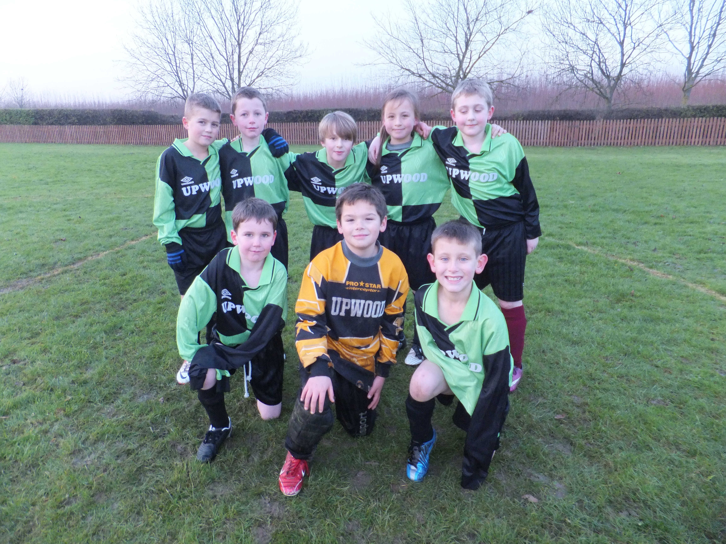
Our School Football Team

Volunteers In School
There is much to be involved with and enjoy at Upwood. Many activities here are enriched by the active support of parents/carers, and other members of the community, who volunteer to spend time in school each week. These volunteers help with various aspects of school life including listening to children read, cooking, sewing, maths, swimming and clubs. School trips and visits off site would often not be possible without the continued participation of volunteers. The help we receive, whether for a one-off event or regular classroom support, is invaluable and contributes also to the diversity of school life for the children.
If you have any time that you could offer, or a particular skill or talent that you could share, we would love to hear from you. There is a statutory requirement for all volunteers in the school to have a DBS (Disclosure & Barring Service) check. This procedure is handled by the School Office and there are no costs incurred by the volunteer.

The Next Step
The right choice of secondary school is a personal matter. In order to help you make your choice we will support you and your child through this experience and do everything we reasonably can to ensure a smooth transition onto your new school.
The majority of children who attend Upwood Primary School begin their secondary education by transferring to our feeder school, the Abbey College in Ramsey. Others transfer to alternative secondary schools in the area or into private education.
We benefit from a close working relationship with the Abbey College who will invite you to visit their school and deal with any queries you may have.
During their final year at Upwood all Year 6 pupils are invited to spend time in the secondary school of their choice and will be visited at Upwood by a representative from that school. Records of your child’s progress at Upwood will be passed to your chosen secondary school and discussions will take place with the Year 6 teacher.

And Finally...
Whilst every care has been taken to ensure accuracy at the time of publication some details may be subject to change as the school year progresses. We hope that you’ve found our Prospectus helpful and informative. We are always happy to help with any further information you may require and would be delighted to show you around our school. Please contact us through our School Office.
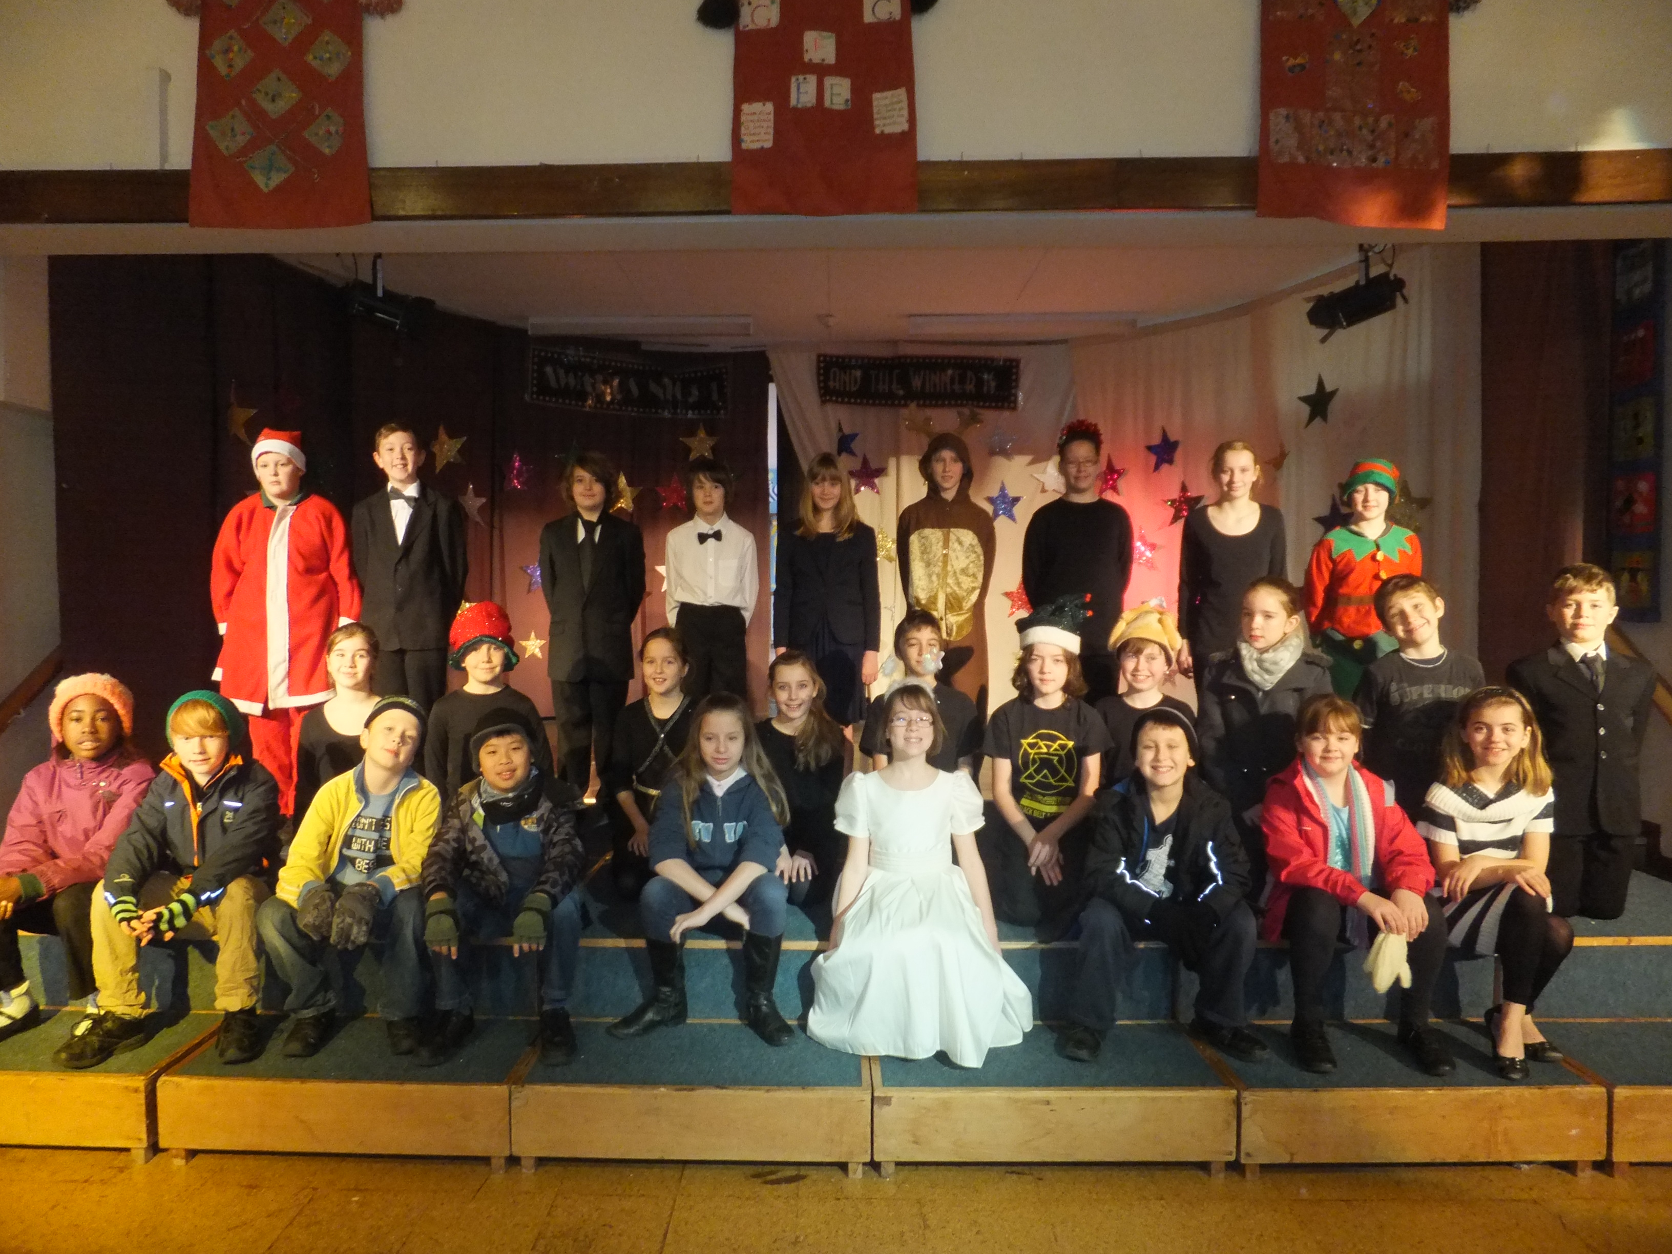
Our Annual Christmas Performance

Appendix A (Documents Referred to in the School Prospectus)
- ‘Members of the Governing Body’
- ‘Upwood Primary School Policy Document: Inclusion’
- ‘Upwood Primary School Policy Document: Admissions’
- ‘Upwood Primary School Policy Document: Internet Use’
- ‘Upwood Primary School Policy Document: Sex Education’
- ‘Upwood Primary School Policy Document: Drug Education’
- ‘Upwood Primary School Policy Document: Special Educational Needs (SEN)’
- ‘Upwood Primary School Policy Document: Homework’
- ‘Upwood Primary School Policy Document: Freedom of Information’
- ‘Upwood Primary School Policy Document: Complaints’
- ‘Upwood Primary School Policy Document: Positive Behaviour and/or School Behaviour’
- ‘Upwood Primary School Policy Document: Anti-Bullying’
- ‘Upwood Primary School Policy Document: Accessibility’
- ‘Upwood Primary School Policy Document: Whole School Food’

Appendix B (Attendance Statistics 2012 - 2013)

The National Average for pupil attendance is: | 95.2%
Pupil attendance at Upwood Primary School is: | 95.8%
Pupil absence is recorded in half-day units, called pupil sessions.  The percentage of authorised and unauthorised pupil sessions missed is: | 4.2%

Appendix C (Key Stage 1 Test Results 2013)
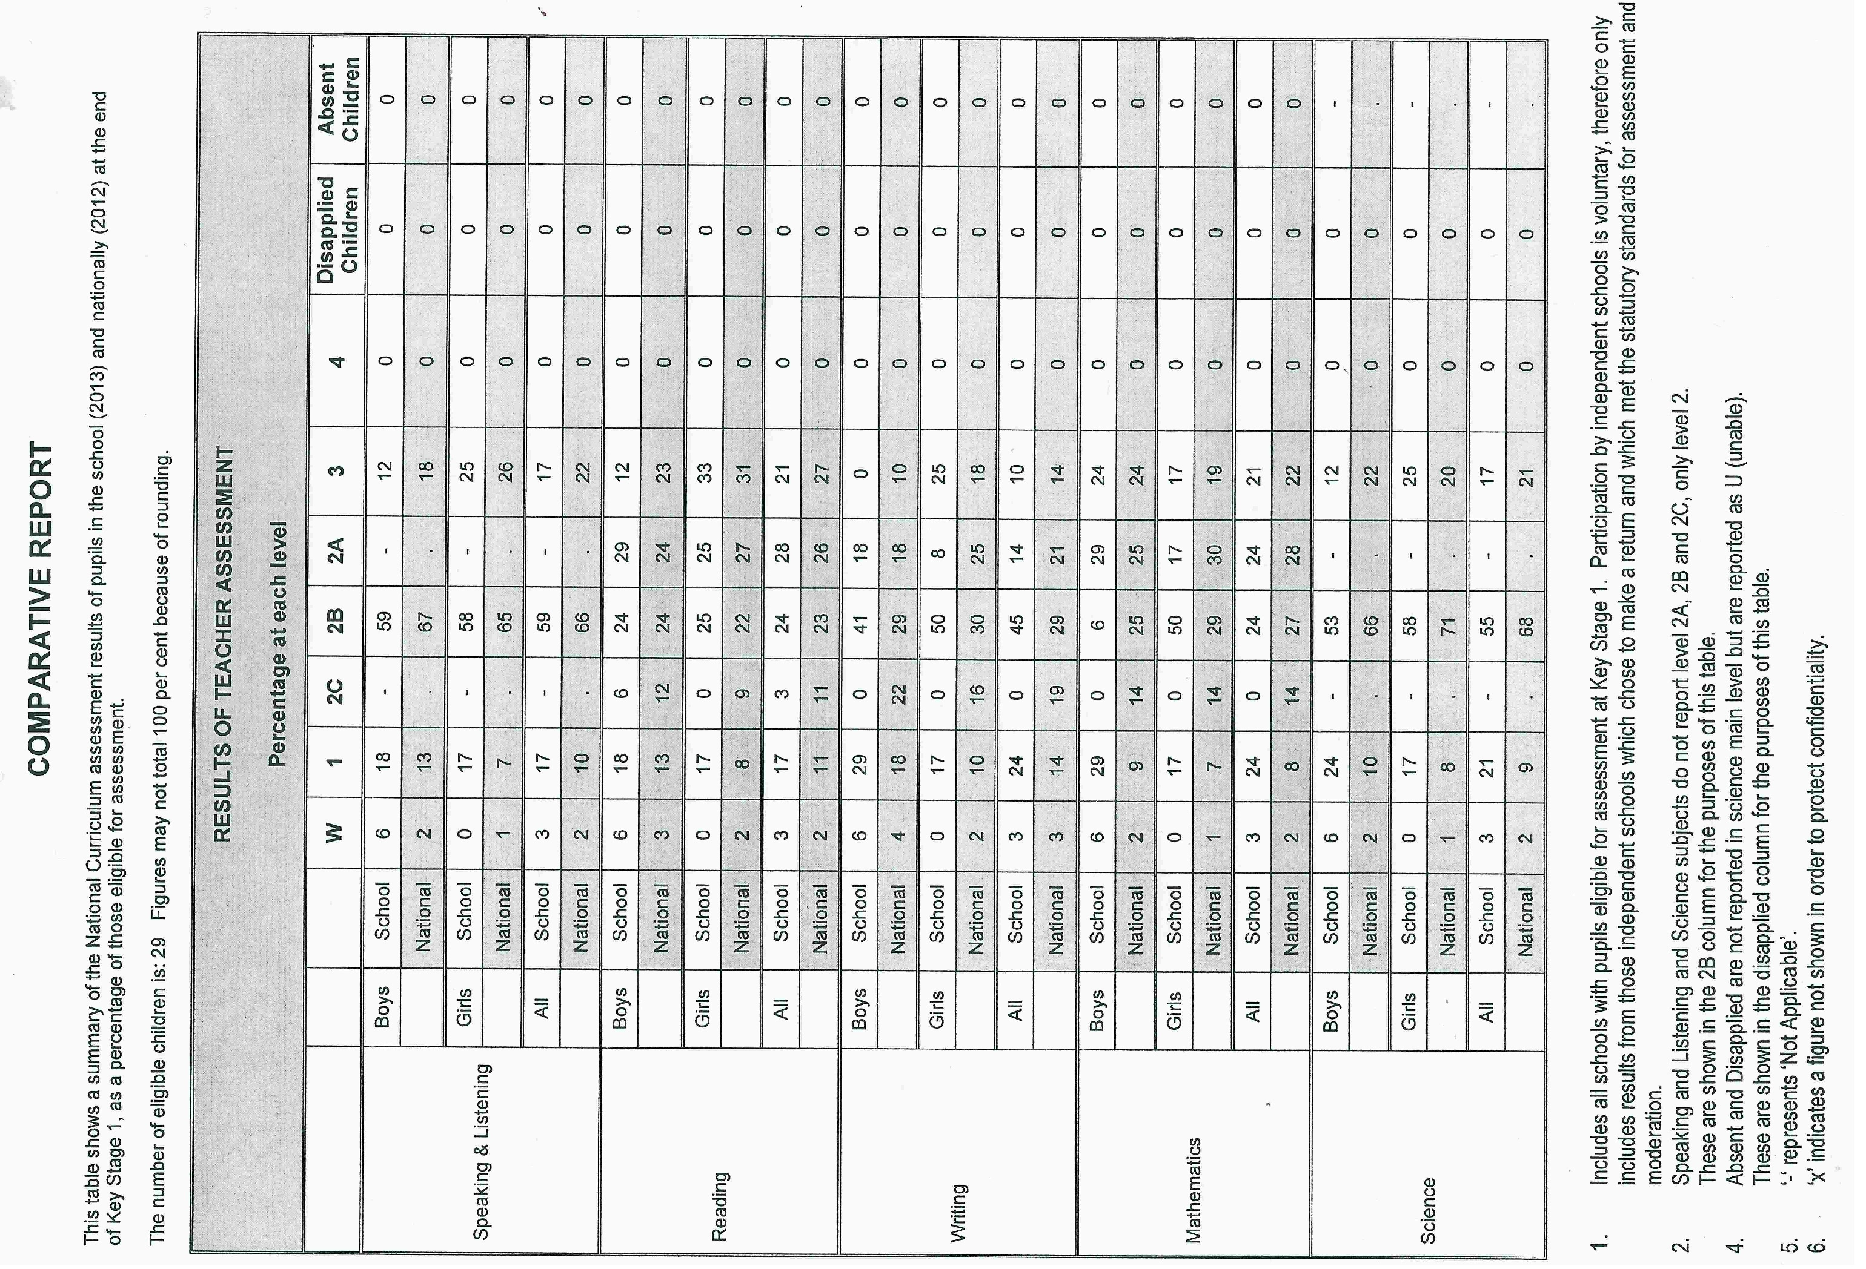

Appendix D (Key Stage 2 Test Results 2013)


